**MARS Reverse Engineering ECG Data Files:**

**HRVY and HRPY Programs**

Jeffrey Day

Maura Franz

Alex Mancera

Hilary Mehler

Stephen Panossian

Analia Treviño-Flitton

University of Maryland Global Campus

BIOT 670: Capstone Project

Dr. Wolfgang Rumpf

March 31, 2021

TABLE OF CONTENTS

Background...................................................................................................................................................4

Client Information............................................................................................................................4

NCH File Conversion Routine...........................................................................................................5

Original Project Goals......................................................................................................................7

Research Conducted.....................................................................................................................................7

MARS Ambulatory ECG System........................................................................................................7

.nat File Research.............................................................................................................................9

Agile Software Development......................................................................................................................16

Heart Rate Viewer in Python (HRVY)..........................................................................................................18

Memory Accommodations............................................................................................................18

Packages........................................................................................................................................19

HeartPy.............................................................................................................................19

Plotly................................................................................................................................19

Supporting Modules.........................................................................................................19

HeartPy Functions............................................................................................................19

MARS Group Functions.....................................................................................................20

HRVY Filtering Algorithm..................................................................................................23

Heart Rate Processor in Python (HRPY)......................................................................................................24

PhysioNet.......................................................................................................................................25

Pandas............................................................................................................................................27

File Conversion..............................................................................................................................27

Running the Program.....................................................................................................................31

UI Design.....................................................................................................................................................32

Dash...............................................................................................................................................32

Overall Design................................................................................................................................32

App Development..........................................................................................................................35

Accompanying Documentation..................................................................................................................38

Users Manual.................................................................................................................................38

Future Updates and Recommendations.....................................................................................................38

HRVY..............................................................................................................................................38

Machine Learning.............................................................................................................38

Anomoly Detection....................................,......................................................................39

Jupyter Notebooks............................................................................................................39

Anaconda Navigator.........................................................................................................40

HRPY..............................................................................................................................................40

Dash...............................................................................................................................................40

Memory Limitations.........................................................................................................41

Miscellaneous................................................................................................................................41

References..................................................................................................................................................42

Appendices.................................................................................................................................................45

Appendix A.....................................................................................................................................45

Appendix B.....................................................................................................................................46

Appendix C.....................................................................................................................................53

Appendix D.....................................................................................................................................56

**Background**

**Client Information**

The Nationwide Children’s Hospital (NCH) is one of the largest not-for-profit children’s hospitals in the nation. It currently ranks 8th best children’s hospital in the US for the 2020-2021 year, according to US News and World Report (2021). NCH offers a wide array of specialties for children, including the largest neonatal unit in the United States, pediatric surgery, and cardiology. In addition to providing excellent care to its juvenile patients, the hospital also participates in several research areas, and is active in the efforts to cultivate fair and equal access to quality care in underserved communities, with an emphasis on behavioral health services. The Abigail Wexner Research Institute at NCH is dedicated to improving the quality of life of children and their families through research specialties which currently include several cardiovascular projects (Nationwide Children’s Hospital, 2021).

One of the most common ways cardiovascular symptoms are observed is through bedside monitoring of heart beats via electrocardiograms (ECG). ECG machines measure and record the electrical signals from the patient’s heart (Mayo Clinic, 2021). The signal output from these devices can be analyzed in a variety of ways, depending on the patient’s needs and the clinic’s resources. Furthermore, the research group working with the primary investigator, Dr. Will Ray, utilizes the MARS systems to analyze heart rate variability (HRV) data from newborn infants born prematurely. One of the areas of application for which the research group uses the HRV data is to identify organ system functionality. More specifically, it is used to check whether the infant is having a normal physiological response to feeding by the activation of blood vessels in the stomach. Recent investigations have been conducted by Pados, Thoyre, Knafl, and Nix (2017), to find additional uses for HRV data analysis in the care of premature infants. The group of researchers utilizes HRV analysis to identify patterns of physiologically stressful feeding methods for the infants. Their investigations observed that when an infant has less physiological stress during feeding, there is an increased amount of feeding. This results in less strain on the infant and promotes growth (Pados, Thoyre, Knafl, & Nix, 2017). This can help identify the most effective feeding method for growth optimization.

**NCH File Conversion Routine**

Our team was tasked with condensing the current HRV data conversion pipeline. The current process flow begins with the HRV data’s origin from the NCH bedside monitors to its General Electric (GE) MARS Ambulatory ECG System is displayed in Figure 1. As the group learned, transforming raw heart rate monitor data into a GE proprietary format for further analysis is a long, convoluted, multi-step process.

**Figure 1**

*Original hospital file conversion flow.*

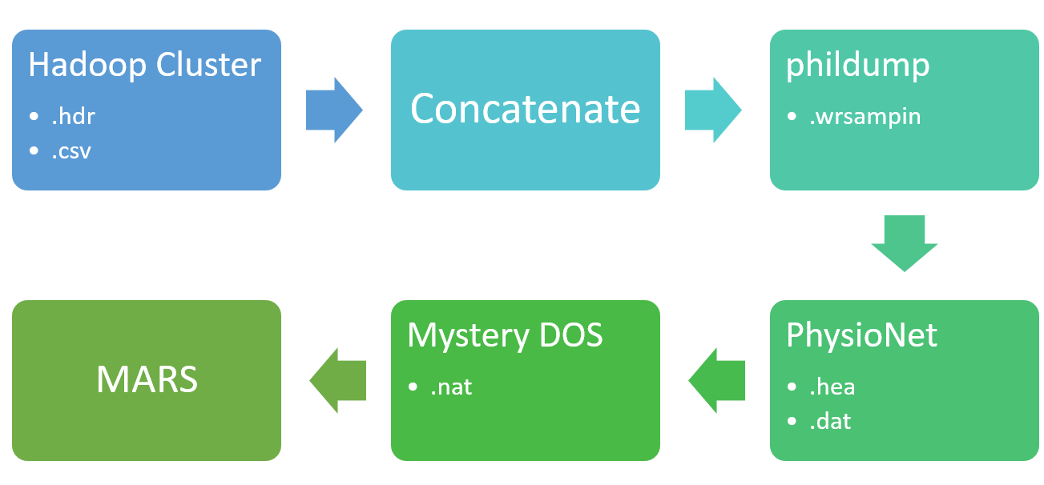

*Note*: *.*hdr and .csv files undergo several conversions to become a .nat file.

NCH’s bedside monitors output data through a Hadoop Cluster, a network of computers that analyze and store large datasets (Databricks, n.d.). These heart rate monitors record data as fast as every 2 milliseconds (2ms) for 24 to 48 hours in each run. Given that 24 hours is the equivalent of 86,400,000 milliseconds, as many as 43,200,000 data points each day can be stored for an individual patient. The Hadoop Cluster then outputs this large collection of data (for an individual patient) from the ECGs into two files, a comma-separated values (.csv) file and a high dynamic range (.hdr) file. The files are then accessible on NCH’s local Linux operating system platform. The .csv file contains a timestamp of the start date and time, and a column of signal reads for each node used in the process. The .hdr file contains further information about the recording nodes, such as the signal type (V or mV typically) and the specified time interval between the reads in milliseconds.

Currently, the hospital’s initial step in the file conversion is a Python program called phildump. This program requires the end user to first concatenate the two Hadoop Cluster outputs--the .hdr and .csv files--before feeding the resultant file into the phildump program. This concatenated file is then parsed out by the program, which is called from the command line prompt. Additionally, the column numbers containing data in the .csv file must be specified in the command line when calling phildump.

The phildump program performs several additional functions apart from converting the two files to a .wrsampin format file for use in the next step in the processing pipeline. It prints several values to the command line during parsing for the end-user to audit. It extracts the node ID, the label, the unit, and the time period from the header lines in addition to the start time and date. The hospital representative forewarned the team that it has several quirks. Although it is able to extract the time period, or the sample frequency, from the header lines—originally stored in the .hdr file—it does not use this to put together the sample times for each reading. Instead it specifies that it will set the interval to 2 ms, but, in actuality, sets the interval to 8 ms as the MARS software requires an input sample frequency of 8 ms. In addition to extracting the start time and date, it also determines the overall highest and lowest values. The necessity for this has not been indicated by the NCH representative.

The main objective of the phildump program, the conversion of the concatenated .hdr and .csv files into .wrsampin format, is to produce a file readable by PhysioNet. PhysioNet then converts the .wrsampin file into an .hea (header) file and .dat (binary data) file. After these conversion steps, the two files are then fed into a mystery DOS converter program, which outputs a .nat file, also known as a ‘tapefile’. The final step of this process is to upload the .nat file into the MARS system for analysis.

**Original Project Goals**

Upon being presented with this project, the group was tasked with reverse-engineering the MARS input file, reducing the file conversion steps to a one-and-done program that would take output from the Hadoop Cluster (.hdr and .csv files), and produce a .nat file that could be read by the MARS software. Upon receipt of a MARS input file example, the group attempted to view it many times to understand its format and how to convert the ECG output files into an acceptable .nat file. It was determined that the .nat file was in hex format, but all attempts to view it failed. Several weeks after the initial meeting with the NCH representative, the group was presented with the news that converting the files into a .nat file would be beyond our ability, and new objectives were communicated.

**Research Conducted**

**MARS Ambulatory ECG System**

In an effort to explore every potential route to accomplish the goals, the group turned its attention to better understanding the MARS system to determine if there were any information about the input file format in the MARS machine’s documentation. After reading through multiple MARS version 8 manuals, it was found that the system refers to their entry ports as “slots.” There are versions of this same model with an updated software system that supports input from multiple sources with differing formats, as seen in Figure 2 and Figure 3.

**Figure 2**

*An excerpt from the MARS V8 Manual with Slot File specification*

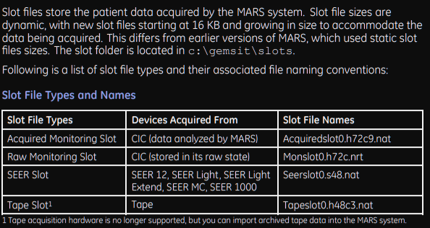

**Figure 3**

*An excerpt from the MARS V8 Manual describing the data specifications for the Slot Files*

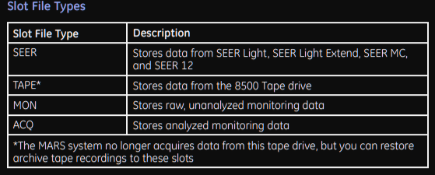

The group was hopeful that the software version the NCH was working with would be one with multiple slot capabilities. This also would have been especially useful considering the MARS manual does provide formatting details for the output files it generates. In a PowerPoint posted online by Dr. Stein, an HRV researcher at Washington University’s School of Medicine (2016), it is suggested that MARS can read back in its output files. However, the PI confirmed that the NCH’s model did not have that software version, so that channel was futile.

The .nat file, the current DOS program output, is written in a GE proprietary format which hindered our ability to successfully open or view the file. After multiple lengthy discussions, each climbing the ladder of authority within GE’s technical support division, the group learned there was no source code or documentation available for NCH’s executable version of the DOS converter program. Furthermore, the origin of the converter program is estimated to date back to the 1990s, which was being run on Windows 3.1. Additionally, there are not only confounding compatibility issues with current-day software, but there are also technical support issues. The original team of software engineers who developed the program for the DOS converter are no longer employed by GE, and the new team at GE can only offer support on the newer version of the MARS software and its functionality.

**.nat File Research**

Initially the most critical component to the project was to study the .nat file format. Group 4 intended to learn about different methods of file interrogation, develop an understanding of the MARS system’s file input requirements, and identify any potential route or strategies to unravel the hidden format. Seemingly, the process of understanding the format of the .nat file, the output from the DOS binary converter program and MARS input file, resulted in the biggest bottleneck to the project’s advancement. Thus, the objective to determine how the input data files were transformed, to recode the transformation to an algorithm in Python, and to code a single program to consolidate the current seven step pipeline, became much more difficult.

During a preliminary search, it was difficult to track down any document of relevance to .nat file formats. The few slivers of information that were found online discussing .nat file extensions, were from various unsupported online forums where the files ranged from mp3 audio, to ebook compilers, and even records of satellite images (File Extension Info, n.d.). The only file that was available to review, to help determine this file format, was the manual for the ECG ambulatory system. Unfortunately, this manual did not relay any information regarding the .nat file, since that information was stored in the actual software. The first step to the group’s file interrogation was to attempt different methods to open the .nat file. File Viewer 4 is a general file examiner and converter that is available for Windows in the Microsoft Store, it supports more than 400 different file formats (File Viewer Plus, 2021). Unfortunately, the .nat file was not recognized by File Viewer 4, but the group was able to inspect the file separately through a text and hex viewer. However, while the viewer was not able to decipher the file, the group was able to determine the file appeared to be more coherent to a human audience when viewed in a hexadecimal (hex) binary file format. Following this discovery, general information about hex files were gathered. Interestingly, hex files are a common intermediary file type from source code produced by C compilers (Kanda Electronics, 2016). In hex files, every one digit of hex translates back to four digits in binary, illustrating that hex files are a more compressed version of traditional binary files. The initial column in hex files, as seen in Figure 4, is called the byte-offset. It is used to record the distance from the beginning of the file, based on the digit index in the file, only tracking the initial digit at the beginning of each line. The byte-offset is commonly viewed as an address for byte placement in hex files.

**Figure 4**

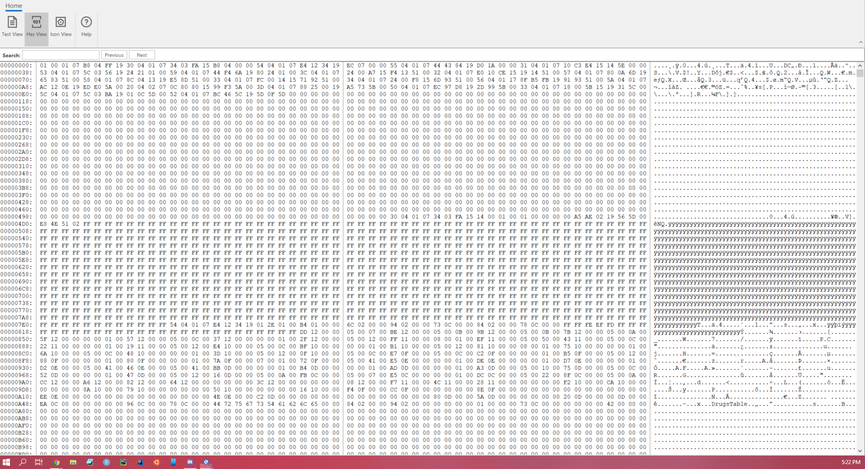*The .nat file in hex view with File Viewer 4*

As the group moved forward with this knowledge, all of the files originating from the NCH’s pipeline, were examined with multiple hex editors to see if a numerical relationship could be gleaned from the converter’s transformation process. The files investigated with this method included the .wrsampin file and .nat file, both of which are in binary file format. *Synalyze It!* for MacOS, Jojo’s Binary Diff program (jdiff) an open-source Linux application available on SourceForge.net, and various Linux commands including filedump, hexdump and objdump were among the tools utilized.

Various attempts were used to harness the functionality of the jdiff patch software in order to identify locations of interest to examine within the original files. In the following example, the Waveform Database (WFDB) file (.dat) obtained using the PhysioNet library wrsamp was compared to the tapeslot (.nat) file provided by the PI. First, a hex dump of each file was created in the Linux terminal (e.g. xxd a_out.dat a_dat.hex). The difference file was then created using the “verbose” option to obtain the summary shown in Figure 5. The summary provided by JoJo’s Binary Diff program confirms the PI’s notion that the DOS converter inserts a significant amount of data, indicated by the drastic difference between Equal bytes and Total bytes, as well as the note that not all data was found in the source file.

**Figure 5**

*Summary from JoJo’s Binary Diff software*

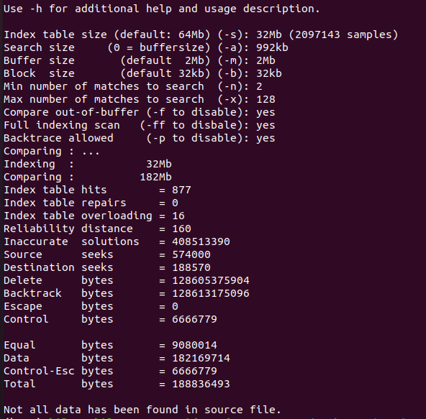

*Note*: Comparison of .dat to .nat hex files, obtained by running the following command: jdiff -vv a_dat.hex a_nat.hex ahexpatch.jdf

In order to determine how to efficiently use jdiff’s functionality, two simple mock files with known differences were created for comparison. These text files were converted to hex, as well as binary files, and the jdiff software was used to create a patch. For the hex files, the jdiff patch file shows the fields that are the same between the two files as a7a3 xx. The last two digits shown in this report as ‘xx’ are variable, and the significance of these digits could not be determined. Similarly, the binary patch file tags identical sequences using 10100111 10100011 xxxxxx. Ultimately, the binary files did not provide an obvious benefit to the group.

To confirm that these tags were unique to the patch file, a simple grep command was performed on both of the hex files used for comparison. Since the a7a3 tag was not found in either hex file, it was proven to be unique to the jdiff patch file. It was thought that this tag could provide a systematic way to locate and examine the differences between two files. As found using files with known differences, in the patch file this tag precedes a difference that is only found in the second file submitted for comparison. In theory, it would be fairly easy to use the patch file to find these differences in the second hex file, then work outward from the differences to find fields that are identical between the two files. Various grep attempts proved this was more difficult than anticipated. When the project changed course, research was in progress to find alternative search commands to grep, preferably with options to ignore white space and include multiple lines in the output. Also sidelined, were plans to run jdiff again using an option that provides more accuracy at the cost of memory.

The *Synalyze It!* software was also used to determine binary file differences between the .dat and .nat files, as seen in Figure 6. Here, Jojo’s Binary Diff program, jdiff, computed the binary differences between a sample .dat file and a sample .nat file. The resulting .jdf binary difference file, was viewed with the same intention of identifying any type of numerical relationship between the files that could be used to develop a transformation algorithm.

**Figure 6**

*Sample comparison of files*

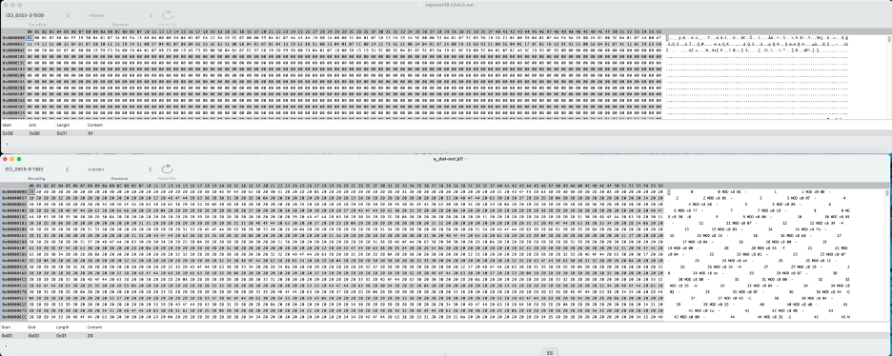

*Note*: .nat and .jdf files in hex format using Synalyze It! Software (Pehnack, 2009).

However, after several unproductive days cycling through all 270+ binary formats available in *Synalyze It!*, reverse-engineering the DOS converter program through this route was determined to be unproductive. Along the same path, another analysis was conducted using many different online hex compilers, encoders, and translators. The online converter hosted by OnlineHexEditor.com, was able to provide some type of insight into the file structure by identifying 183 image object entries in the .nat file. Furthermore, the software noted there were only a total of 15 image objects that were discernible or complete (OnlineHexEditor, n.d.). Additionally, open-source encoder/decoders online identified encoding in the file that was similar to two different formats, ISO_8859-1:1987 and ISO_8859-9:1989, but neither of them were a complete match. This led the team to believe the DOS converter utilizes more than one type of encoding for the .nat file format. With the utilization of the Linux command objdump, the assembly form of the .nat file revealed more distinct characteristics to the file as seen in Figure 7. The file format is not only a mix of little and big endian, it also does not have a row of magic numbers denoting it is not an executable linkable file. From this piece of information, the team was able to determine the .nat file does not perform any action, this aligns with the information the PI shared.

**Figure 7**

*The results from objdump after processing the .nat file.*

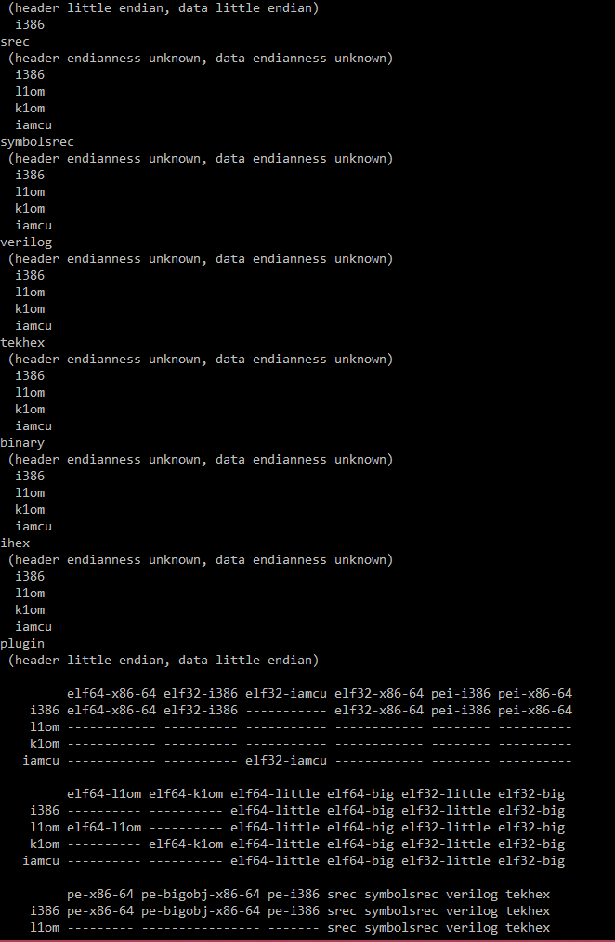

The WFDB module documentation indicated that the data undergoes the two’s complement and identified its least significant bit ordering; however, no other formatting is described. Thus, the group’s ability to specify the binary format was proven to be more difficult and unrealistic to determine within our given timeframe.. Furthermore, reverse-engineering binary files in the computing industry is generally known to be both a prosecutable offense, and one of the most difficult tasks in programming.

If the group had been able to reverse-engineer GE’s proprietary format successfully and create a transformation algorithm, they could have faced substantial legal issues. According to the “What is Copyright?” website of the U.S. Copyright Office, software copyrights last "95 years from publication or 120 years from the moment of creation, whichever is shorter." Thus GE still has legal ownership of its software to transform data into its proprietary format for many more years to come.

Given that none of the team members were/are proficient in reverse-engineering, nor could the transformation algorithm be determined, the only conclusion that could be drawn was that they did not have the abilities to replace this software component. The principal investigator for the project agreed, and also approved the refocus to deliver a data processing application and a data viewing application.

**Agile Software Development**

**Figure 8**

*Visual depiction of the Agile Lifecycle. SaigonTechnology.com*

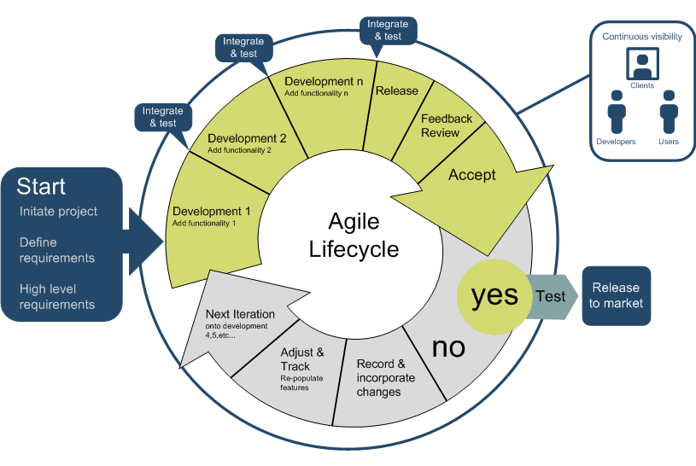

The software development lifecycle (SDLC) has grown to include a number of different methodologies based on the characteristics central to the standard phases of development. The SDLC phases include planning, requirements analysis, design, implementation or development, testing, deployment, and maintenance. The experimental nature of reverse-engineering the MARS input file greatly influenced the selection of the project management and software development methodology that would be most fitting and effective in advancing our team’s objective forward. The Agile development method was chosen to be best suited for this project given that the integral goal was contingent on researching and deciphering the .nat file (depicted in Figure 8). This approach led the planning phase to occur throughout the SDLC of the project.

The Agile philosophy has taken center stage with, as of 2016, approximately 94% of software development-focused organizations practicing the Agile method (Altexsoft, n.d.). This approach has become viewed as the gold-standard in the tech industry, with exceptions based on project specifications. Agile is guided by a set of core principles that prioritizes dynamic engagement within the team of developers rather than following a rigid structure based on processes. The theory behind this approach is that people work more effectively when they are allowed to organically collaborate on a project, make adjustments to the plan-of-action as needed, and adapt to new changes as discoveries are found. This mirrors the initial stage of the group’s research and development phase with respect to the .nat file. Generally, it is not uncommon for project goals to change as the developmental life cycle of a project matures. The group experienced this first-hand as the overall knowledge base of the objective continued to improve. Due to this recurring trend, Agile concentrates on developing functional products first, with the documentation phase occurring after development has been underway.

**Heart Rate Viewer in Python (HRVY)**

**Figure 9**

*HRVY Logo.*

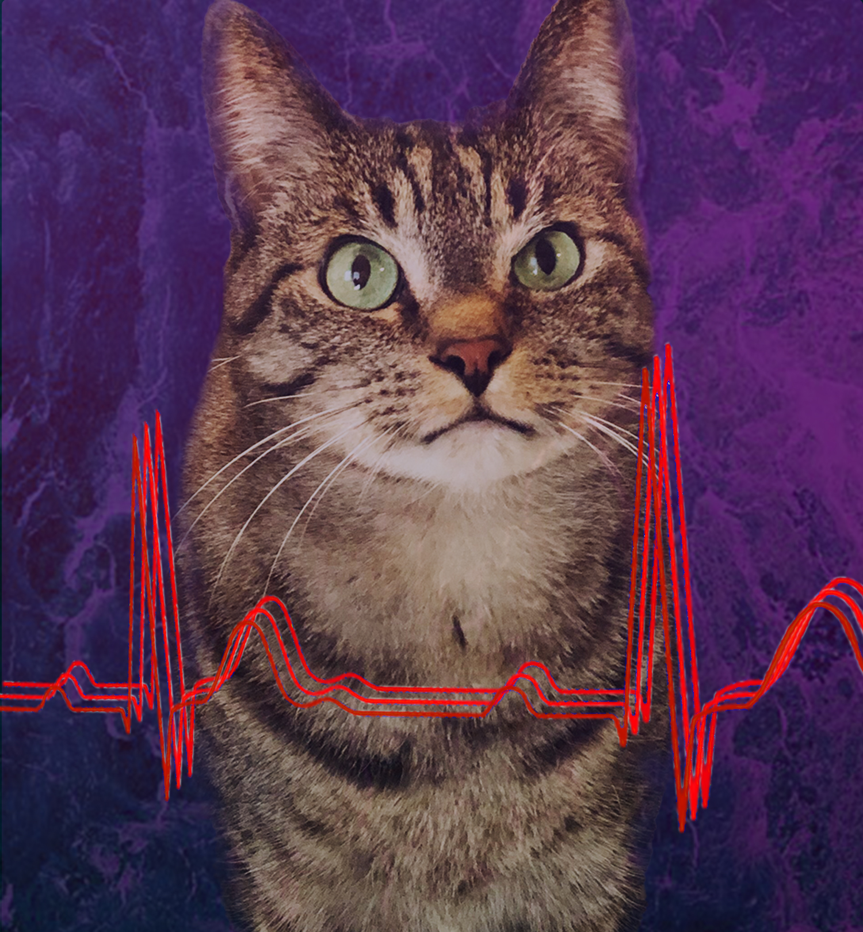

*Note*: Modelling for the logo is Harvey, one of the programmer’s cats. Graphic Illustration By Analia Treviño-Flitton.

**Memory Accommodations**

In an effort to enhance the overall processing time and to compensate for the computationally expensive files, the code was refactored following the Agile methodology. The changes supported the accepted object oriented programming (OOP) principles standard to software engineering guidelines as described by Ramachandran, (2012). The main OOP components utilized in refactoring HRVY were focused on reformatting the program’s structural framework to allow for increased processing speed. This was necessary for the development team as some of the members were having difficulty running the test files on their machines due to memory allocation. To decrease the memory needed and improve the performance, the group utilized modules of functions where commonly used variables could be recycled and passed throughout the program when needed. This also helped the team isolate bugs in the code during test runs. Additionally, it was determined that memory could be saved by importing the open-source packages from within the specific functions they were used, rather than importing them all at once from the beginning of runtime. In total, we implemented a one-time read of the large input files, where the data was sent to variables for reuse, it resulted in an increased performance and provided more precise debugging. Furthermore, we incorporated clearing objects once they are no longer needed in subsequent functions or processes, to free-up additional memory. An example of this method can be seen with the emptying of the dictionary hdr_dat at the end of the align_plus_dat() function in HRVY.

**Packages**

***HeartPy***

HeartPy is a free and open-source Python toolkit for heart rate analysis, capable of processing both electrocardiogram (ECG) and photoplethysmogram (PPG) data. The HRVY application calls several HeartPy functions for the preprocessing of the raw input ECG signal data.

***Plotly***

The free Plotly Python Open Source Graphing Library was used to output the processed signals as plots in separate windows (one plot per window).

***Supporting Modules***

NumPy and SciPy are two free open-source Python modules containing low-level functions that provide mathematical and math-related processing, in addition to science and engineering processing. They were utilized respectively in the development and execution of HRVY.

***HeartPy Functions***

**remove_baseline_wander:**

The remove_baseline_wander function is a package HeartPy designed to use sub-level HeartPy functions to filter and correct baseline wander. This function requires only the sample rate calculated using HeartPy’s get_samplerate_datetime() function, to correct the data so the baseline is as flat as possible.

**smooth_signal:**

HeartPy’s smooth_signal() filter also uses sub-level HeartPy functions to reduce low-level background noise in the signal. The smooth_signal() function requires the sample rate (calculated using HeartPy’s get_samplerate_datetime() function), window length, and polyorder. We found best results correcting the provided test datasets with a window length of 16 and a polyorder of 3.

**get_samplerate_datetime:**

HeartPy’s get_samplerate_datetime() filter is used to calculate the specific sample_rate for each dataset. The get_samplerate_datetime() function requires only the datetime format to be provided along with the dataset containing the datetime values.

**flip_signal:**

HeartPy’s flip_signal() filter which uses sub-level HeartPy functions to invert the signal of an entire dataset. The flip_signal() function requires two boolean selections: whether or not to turn on the enhancepeaks (peak accentuation) filter and/or to keep_range (maintain original range). For our datasets, we used enhancepeaks = False and keep_range = True.

***MARS Group Functions***

**flat_peak_reduct:**

This function has two main parts: reducing flat peaks that are over 20 ms long and reducing steep peaks that are impossibly tall. The flat_peak_reduct() function is the first correcting function applied to the raw data to clean up anomalies in preparation for baseline correction.

This function was introduced as a way to help slightly correct the data before running the remove_baseline_wander() function for baseline wander correction. Originally, when running the baseline correction first, we noticed that some ECG plots had a sharp curve. We then realized that some datasets had segments of identical values maintained for relatively long periods of time. Some of these long, flat segments were found at the beginning of the dataset before the heart beats actually started, while other segments occurred among other heartbeats, as a result of very tall peaks that had been cut off at the window maximum (around +/- 40 mVs). Running the baseline correction without accounting for these data anomalies would cause the entire baseline of our graph to curve sharply because the program assumed that these were very tall heartbeats and curved the entire graph to fit them into an expected baseline. We decided to identify segments of identical, repeated values sustained for more than 10 data points (10 x 2 ms = 20 ms) and flatten them down to the baseline (assumed to be 0.5) to correct this error.

The second part of this function was originally its own separate function, but was merged into flat_peak_reduct() to avoid iterating through the data a second time. This part of the function detects changes in the slope (difference between the current data point and the previous data point) in the unaltered data, collects data whenever the slope is considered not_flat (slope of +/- 0.05), checks for steep_slope (slope of +/- 0.5), checks if there is a steep slope and inverse steep slope (what goes up must come down, and vice versa), and stops recording data when the slope becomes less than or equal to the not_flat value (slope of +/- 0.05). For segments that contain a starting steep_slope and inverse steep_slope, as well as a max/min data point (most_dif_val) that is greater than 3mVs from the starting value, the entire segment in the original data set is replaced with a straight line by taking the average of the starting and ending values. This essentially slices the steep_slope off at the base and eliminates it entirely from the dataset. In cases when a data monitored segment reaches 50 data points and no steep_slope is detected, the segment is reset and again starts searching for a slope that is steeper than not_flat. Both sections of flat_peak_reduct() have checks in place to avoid interfering with each other. All of the data measures can be adjusted as needed for different datasets.

**tall_peak_reduct:**

This function also has two parts. The first part of the function works almost identically to the second part of reduce_flat_peaks(). The program starts recording data from starting with a not_flat slope, searches for steep_slope, and stops recording at the next not_flat slope. Here, the not_flat value is slightly flatter (+/- 0.01) because baseline correction has been conducted and the baseline is essentially flat, except for some minor curvature. The steep_slope value is also not as steep (+/- 0.3) to try to account for more peaks. The most_dif_val value is also slightly smaller (2 mVs) just based on observation of the provided data sets. There is no need to account for flat peaks this time so some checks that had been in place with flat_peak_reduct() were removed. As before, all of the data measures can be adjusted as needed for different datasets.

The second part of the function detects inverted peaks. Just as before, the program starts recording the data with a not_flat slope and records data for 1000 data points. If a peak that is too steep (slope steeper than the steep_slope value) or tall (value outside of the provided scale_max) is detected, the selection is reset and again starts searching for a normal dataset of 1000 data points. Once a normal dataset is found, analysis of the data is conducted. If at least 75% of the data points are found in the top half of the range of values in the dataset, that section is likely inverted. On the other hand, if at least 75% of the data points are found in the bottom half of the range of values in the dataset, that section is likely normally oriented. The “guess” of the likely orientation of that selection is recorded and a new selection is found. At the end of the full dataset, the recorded “guesses” and the frequency of each “guess” are analyzed. If at least 60% of the “guesses” are that the full dataset contains inverted data, the user is notified and the full dataset is automatically inverted using HeartPy’s flip_signal() and scale_data() functions.

***HRVY Filtering Algorithm***

First, within the signal, any segment of ten (20 ms) or more identical data points (due to clipping of signal’s peaks that are larger than the defined range) is detected and then corrected using a team-developed function “flat_peak_reduct().” This same function also detects unnaturally steep/tall peaks and slices them off at the base. Output from flat_peak_reduct() is input into the HeartPy function “remove_baseline_wander()” to eliminate baseline wandering interference, which is usually due to electrode-skin impedance mismatch or motion artifacts, such as a patient’s body movement or respiratory breathing (Shin et al., 2015). Next, the data is scanned for additional tall/steep peaks that might have been automatically created as a result of the “remove_baseline_wander()” and reduces them down to the baseline. During the process of scanning for tall peaks after baseline correction, the data is also scanned to determine if the data is inverted. If inverted data is found, the entire dataset is then input into the HeartPy “flip_signa()l” function, which inverts the entire dataset while maintaining the same range of values. Finally, HeartPy’s “smooth_signal()” function is called to smooth the input signal using a Savitzky-Golay filter. The output data list from smooth_signal() is then replaced with the original list and with a 1-dimensional numpy array nested in a tuple.

**Heart Rate Processor in Python (HRPY)**

**Figure 10**

*HRPY program mascot. Harpy Eagle free clip art image from Designlooter.com. Graphic Illustration By Analia Treviño-Flitton.*

HRPY was developed to convert output data from the Hadoop Cluster, .hdr and .csv files, into MIT file format, .hea and .dat files. MIT file format can then be used in the DOS Mystery converter to produce the .nat file necessary for the MARS program. Two open-source libraries were utilized in HRPY’s development, the WFDB library from PhysioNet and the Pandas library were used as described below.

The files input to the mystery DOS converter consist of a text header file (.hea) and a binary data file (.dat). These are also referred to as the MIT format. The MIT header files store information necessary for follow-up software to understand the data file’s location and format (PhysioNet, 2017). There is also an option to include comments in these files that can house patient information. The actual data from the original file is then stored in .dat file format. These files store the signal in binary format (PhysioNet, 2017). These binary files are most commonly stored in 16 or 212 bit format, and the format used is specified in the header file (PhysioNet, 2017).

**Figure 11**

*New process flow. HRPY takes files from the Hadoop Cluster and converts them to .hea and .dat format for further conversion via the Mystery DOS converter.*



**PhysioNet**

The .wrsampin file, output by the phildump program, is a type of .wrsamp file. A .wrsamp file is an intermediate step to writing WFDB files (Moody, 2019b). PhysioNet’s WFDB library was chosen because NCH uses PhysioNet to convert .wrsampin into .hea and .dat files. The WFDB library is a Physionet package for Python that contains functions that are able to read, write and process WFDB data (Python, 2021). This library was originally designed for use with ECG data (Moody, 2019a). Several functions have been developed that convert various ECG monitor outputs to MIT format for further analysis. None of these functions are built to convert the output file from the hospital’s phildump program (a .wrsampin file) into .hea and .dat files.

Since NCH’s current process takes the .wrsampin file and feeds it through PhysioNet to convert it into .hea and .dat files, it was assumed the WFDB library would also have a function capable of this conversion. Unfortunately, no WFDB functions exist to carry out this conversion. However, the WFDB database was recently revised to include a function that converts data stored in .csv format to MIT files as part of the wfdb I/O (input/output) directory. This function takes .csv files and produces .hea and .dat files (wfdb, n.d.), allowing the removal of the conversion step of .csv to .wrsampin. It also means the .csv file can be read by the function itself instead of being fed into a Numpy array as other WFDB functions would require. The wfdb.io.csv2mit() function was committed on 2/25/21 and, if the machine already has the library downloaded, requires an update to the wfdb library to version 3.3.0 in order to use it.

The wfdb.io.csv2mit() function requires the name of the .csv file being converted. Additionally, sample frequency and units are normally added as they vary from sample to sample. The file name must be input as a string. The sample frequency can be input in any float format, but the value must be greater than zero (0). The sample frequency is equivalent to the number of samples taken per second, and the HRPY sample frequency can be calculated based on the time interval indicated in the .hdr files (2 ms, 4 ms and 8 ms are the most common time intervals for the data). If no value is specified, a sample frequency of 250 or a 4 ms interval is assumed by the function. Units are also frequently input into the function. If more than one column of data is present in the .csv file, the units may be passed into the function as a list of strings if different units are used. Otherwise, units of mV are assumed. Data column labels may be entered as arguments in the function or as part of the .csv file. As pandas will be used to read the .csv file (see the following section), labels will be added to the columns using pandas instead of as arguments to the MIT function. Additionally, parameters surrounding sample start time and date can be specified. As this information is included in the .csv file, it can be parsed out and added to the function. This information will be contained in the header file. The MARS program could possibly utilize the header in its display of the data and its information could be useful to clinicians, therefore this information is included in the wfdb.io.csv2mit() arguments. Several other parameters can be adjusted as needed, however the other available arguments will not be utilized in this program.

**Pandas**

The MIT conversion function from WFDB requires the .csv file to consist of data columns with or without labels/headers. The ECG output files from NCH are not formatted in this style, therefore the file must be parsed out before being fed into the function. Pandas has proved to be a useful tool for reading and storing data contained in .csv files. The .csv file is passed into a data frame using pandas.read_csv(). The resultant data frame is modified by removing the first column, which contains a date and time string but no ECG data. The date and time are saved to a variable in a later function and reformatted to fit MIT requirements. Furthermore, headers are added to the data column(s). These headers are pulled from the .hdr file and placed into a list. This list is then used as the input for the “names” argument in pandas’ function for reading a .csv to a data frame. This data frame is modified in later functions to fill in data gaps and ensure all values are floats.

When pandas reads .csv data into a data frame, it automatically adds an index column (Pandas, 2021). This index column is not useful to us and would be read into the final wfdb.io.csv2mit() function and cause trouble, so it must be removed. Luckily, the pandas.DataFrame.to_csv() function allows us to drop the index column by setting the “index” argument to “False.” This argument is used after the data contained within the data frame has been edited for completeness. The resultant .csv file contains information that is in the proper format for using the wfdb.io.csv2mit() function.

**File conversion**

HRPY takes the ECG output files (.csv and .hdr) as input. It extracts the information contained in the .hdr file and stores them in lists for later use. It takes the .csv file, removes and stores the date and time information contained in the first row and column, and enters them into the final data transformation function. Additionally, headers are added to the columns. HRPY uses the ID from the .hdr file as a header. It adds “ID” to the front of the ID number because in all sample files provided, the ID has been a number. The WFDB file conversion function outputs a warning when the header row contains numbers as a number could be data instead of a header.

The program then proceeds to find and fill in any gaps in the data. Because each row corresponds to a new timestamp, no gaps are removed. Times are not stored in the .dat file, therefore, removing any gaps in the data would not remove the corresponding timestamps and the end result would not show an obvious gap. Since the importance of the timestamps is not known, gaps are filled in by finding the average of the last valid value and the next valid value. While this is not ideal, the final file transformation function is unable to interpret blank spaces.

The data is further adjusted by ensuring the final sample frequency is 8 ms. This sample period has been specified by the client as necessary for MARS software evaluation. The program accomplishes this by two different functions. One function is used if the original sample period is less than 8 ms. This removes values that are not at 8 ms intervals by utilizing a conversion factor found by dividing 8 by the sample period. For example, if the original sample period was 4 ms, the conversion factor would be 2. Any index from the original data column that is not divisible evenly by two will not be added to the new data column. This takes place before the data columns are repaired. The second function adds theoretical data points when the sample period is greater than 8 ms. In this function, the conversion factor is found by dividing the sample period by 8. This conversion factor is then used to determine the number of samples to be added. For instance, if the original sample period is 16, the conversion factor is 2. One is always subtracted from the conversion factor, so one theoretical read would be added to the data column. This theoretical value is found by taking the average of the last read and the next read. This function is called after the data columns have been repaired.

After repairing the data columns and setting the sample period to 8 ms, HRPY uses a data frame to output the data into a new .csv file. This new file is then read by the final conversion function, WFDB’s csv2mit(). The program also takes the sample frequency, start date and time, and units. These are output in the final header file shown below.

**Figure 11**

*.hea file example*

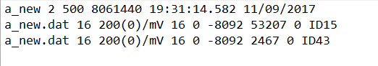

*Note*: HRPY outputs a header file (.hea). The first line is the record line. Any other lines present (two in this case) are signal specification lines.

The header file contains two types of lines: the record line and signal-specific lines. The record line contains information pertinent to all signals (WFDB, 2019). The record line in the header file pictured above tells us the name of the input file, the number of signals, the sampling frequency (number of samples per second), number of samples per signal, the base time and the base date. The signal-specific lines contain the output file name, the storage format of the data (16 bit amplitude in this case), the ADC gain, the baseline ADC units, the units of the signal, the ADC resolution, the ADC zero, initial value, checksum, block size, and description (in our case, it is the column header/ID number). See Table 1 for definitions.

**Table 1**

*Header file definitions*.

|  |  |
| --- | --- |
| File name | The name of the file in which samples of the signal are kept. |
| Format | Integer that specifies the storage format of the signal. All signals in a given group are stored in the same format. The most common formats are format 8 (eight-bit first differences) and format 16 (sixteen-bit amplitudes). |
| ADC gain (ADC units per physical unit) | Floating-point number that specifies the difference in sample values that would be observed if a step of one physical unit occurred in the original analog signal. |
| Baseline (ADC units) | Integer that specifies the sample value corresponding to 0 physical units. If absent, the baseline is taken to be equal to the ADC zero. |
| Units | Type of physical unit |
| ADC respolution | Specifies the resolution of the analog-to-digital converter used to digitize the signal. |
| ADC zero | Integer that represents the amplitude (sample value) that would be observed if the analog signal present at the ADC inputs had a level that fell exactly in the middle of the input range of the ADC. For a bipolar ADC, this value is usually zero, but a unipolar (offset binary) ADC usually produces a non-zero value in the middle of its range. Together with the ADC resolution, the contents of this field can be used to determine the range of possible sample values. If this field is missing, a value of zero is assumed. |
| Initial value | Specifies the value of sample 0 in the signal, but is used only if the signal is stored in a different format. If this field is missing, a value equal to the ADC zero is assumed. |
| Checksum | A 16-bit signed checksum of all *samples* in the signal. A value of zero may be used as a field placeholder if the number of samples is unspecified. |
| Block size | This is an integer and is usually zero. If the signal is stored in a file that must be read in blocks of a specific size, however, this field specifies the block size in bytes. All signals belonging to the same signal group have the same block size. |
| Description | A description of the signal. |

*Note:* Definitions are taken from PhysioNet’s webpage on WFDB header format at <https://www.physionet.org/physiotools/wag/header-5.htm> (wfdb, 2019).

**Running the Program**

Currently, HRPY does not have a user interface outside of the command line. It was originally planned to tie the two programs together so the end user could run them through the same platform, however the accelerated timeline restricted the UI team to focusing primarily on the viewing program. Additionally, the current system that runs the viewing program runs into issues due to memory capability while examining the files provided by NHC in their entirety. HRPY was therefore modified to take in arguments from the command line. It requires only two arguments: the header file name with its ‘.hdr’ extension, and the data filename with its ‘.csv’ extension. This is very similar to the end users’ current process which requires the concatenated file and column numbers. However, HRPY does not require concatenation of the .hdr and .csv files, and it was written to extrapolate relevant data columns without user input. While running the program, HRPY will print to the screen the .hdr and .csv files indicated by the user (this ensures they were entered in the proper order), the IDs, units and frequencies to be used, the columns to be examined, and it will indicate when it is working on a particular column. The program produces three files: the modified .csv file, an .hea file and a .dat file. All three have the same file name with different file extensions. The new files are named by using the original .csv file name and adding “_new” to the end.

Because HRPY is run using the command line, our team recommends the end user save the program to the same directory where input files are kept and where output files are desired to be stored. This will eliminate the need for file paths.

**UI Design**

**Dash**

The Dash framework was chosen because it is highly compatible with Plotly, which the team had previously decided to use to build interactive plots. Graphing interactivity is provided by Plotly, for example, the ability to zoom in and out or to select graphing options (lines or traces to view) as is shown to the right in Figure 12. Plotly also allows the user to upload the graph as a picture (.png).

Dash provides a way of incorporating the HTML and Java components needed for interactive user interfaces into code written in Python. Dash code consists of a section in which we define components, such as a text box or graph. We can then provide functions to these components using callbacks and associated functions, each of which takes one or more input and returns one or more output to a visual component. Dash provides an interface in which user interaction will call the data processing and graphing functions previously described. The primary user action needed to facilitate the ECG viewing application is data file upload (input).

**Overall Design & Function**

Since a robust user interface was originally a ‘bonus’ goal after reverse engineering of the MARS input file was completed, the team had limited time to learn the intricacies of Dash in order to incorporate all desired components and functionality. Prioritization was of utmost importance. A plan was put together to first allow the user to upload data files and view the Plotly graph before incorporating additional functions. In addition, an editable text area would be provided to the user so the researcher may type notes while viewing the ECG data points. The end application looks very much like the initial outline (Figure 12); however, the text area is also used to provide status updates to the user and the option to export the text as a file has not been incorporated due to time constraints.

**Figure 12**

*Dash layout*

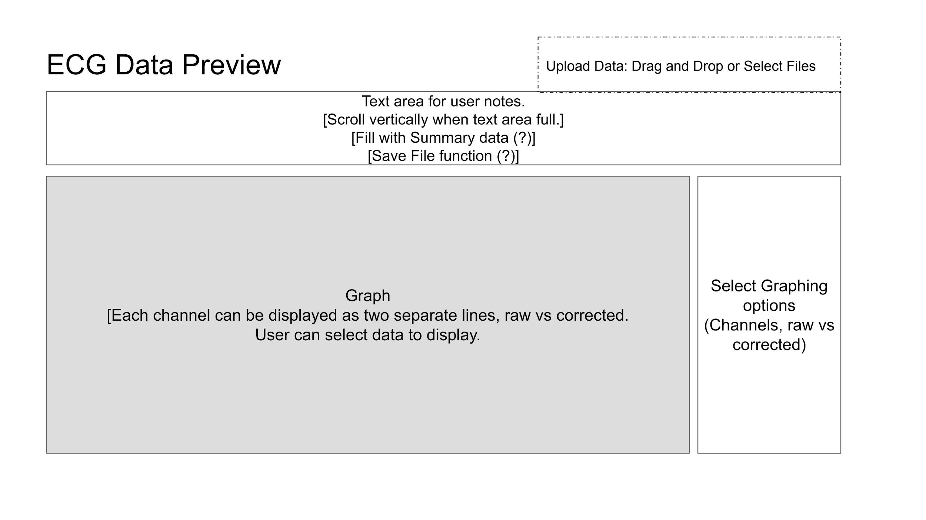

*Note:* Wireframe depicting basic layout of Dash application and several main functionalities.

The Dash application currently has two callbacks. Both take information from files uploaded by the user. The first callback takes the file names as input and returns text to the text area below the title (Figure 12). This function provides updates and instructions based on the file names, extensions, and number of files uploaded.

The upload component allows the user to select any number or type of files, while the application expects one .hdr and one .csv with matching names. If the user has uploaded a file with an incorrect extension, a message will appear saying “Please check your input files. Invalid file extension detected.” Likewise, if more than two files are detected the text area will populate with the following message: “Please check your input files. Upload one .hdr and .csv for a single data set.”

After the correct input files have been detected, the text area will display a message “Plotting [data file name]… You may enter your notes here”. Since the data sets are large, it takes a significant amount of time to build the plots. Without a status update, the user would easily think the program has frozen or crashed.

The second Dash callback takes the file names and file contents from the upload component as input and uses the information to call all ~~of~~ the data processing and graphing functions needed to produce an interactive plot using Plotly. Dash stores the contents of each uploaded file in a base64 encoded string that can then be accessed by the application. When a user uploads two or more files, the file names and file contents are stored in separate lists. Although the components of each file are not explicitly tied together, the lists are ordered so that the contents of a certain file name may be accessed. In order to process the contents, the encoded string must be decoded using the base64 package then stored in memory as a file-like object using io.StringIO. This object is then processed as any other input file. In other words, in order to incorporate the Dash upload component there was no need to change the Python functions written to process local .hdr and .csv files using the command line.

The Dash application may be viewed in a browser while the Python script is running locally or by visiting <http://hrvy.herokuapp.com/> (Figure 13). The deployed application allows a user to demo HRVY using a small data set while avoiding the need to install dependencies, as all dependencies are installed on the server for deployment. However, Heroku places memory limitations that prevent the processing of large data sets.

**Figure 13**

*A screenshot of the HRVY Dash application after files as.csv and as.hdr have been uploaded by the user.*

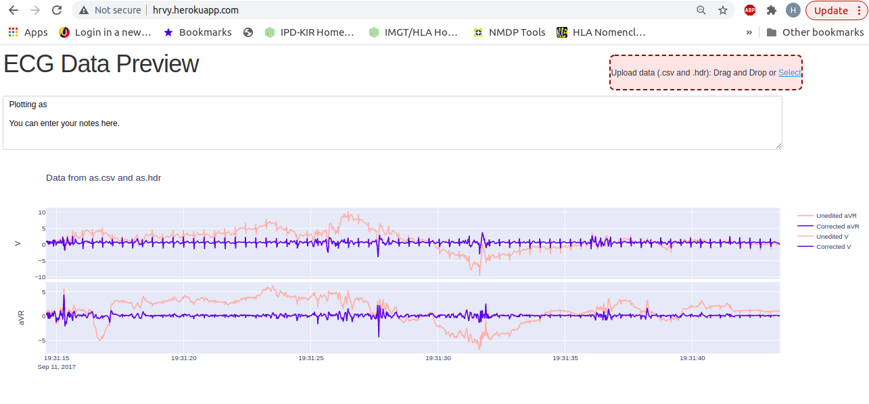

*Note*: The line traces may be hidden or viewed by clicking the name to the right (e.g. ‘Unedited aVR’).

**App Deployment**

Deployment of the Dash application to a server allows the creation of a virtual environment in which the application is known to run without error. The Web Server Gateway Interface (WSGI) is a Python Enhancement Proposal (PEP) specification that describes a standardized interface between web servers and web applications written in Python. WSGI aims to simplify functions as much as reasonably possible while supporting middleware components to provide services to the application that may not be available through the operating system.

Heroku is a cloud platform that supports several coding languages including Python. Using Heroku, developers can easily deploy and maintain web applications from the command line.

The Heroku Dev Center provides thorough instruction for installation on all operating systems (https://devcenter.heroku.com/articles/getting-started-with-python#set-up). It is important to note that Heroku only needs to be installed by developers who are charged with deploying and maintaining an application. Once deployed, any user may access the app without the need to install Heroku or any app dependencies.

Specifically, the Heroku Command Line Interface (Heroku CLI) was installed on an Ubuntu system using the following terminal command:

$sudo snap install heroku –classic

In order to use the Heroku CLI, the developer must set up a (free) Heroku account and install Git, the version control system used by Heroku to store application files and code.

Once installation is complete, the application is deployed using a series of commands described in Table 2. The project directory is created on the local machine before it is pushed to Github for access by Heroku.

Several project files are required, the contents of which are provided in Appendix C. The Python application code is contained within app.py, a naming convention for Dash apps as the filename is contained in many processes such as the Procfile described next. The Procfile is a text file without an extension that is required to be in the project’s root directory. It declares the commands that must be run on startup, like starting the web server and running background processes. The Procfile for the HRVY Dash app specifies Gunicorn as the web server. The .gitignore file is a hidden file, meaning the developer will not see it in the project directory after it is saved using the conventional “.gitignore” name. As the name suggests, the file specifies files that Github should ignore. The developer can change certain settings depending on the operating system in order to show hidden files, however, it is unlikely that there will be a reason to edit .gitignore after it is first saved.

The requirements file contains the names and versions of all libraries or packages needed to run the application. This includes Python libraries that are imported and used within the code, such as HeartPy and Plotly, as well as packages required to run the application on a server, such as Gunicorn. All of the packages specified by the requirements.txt file can be installed on a local machine using the command $pip install -r requirements.txt. This action will install all packages required to run HRVY locally but includes additional packages that are not necessary to run the software locally.

When first deployed, the program did not run as expected even though it ran without error locally. Many changes were made to requirements.txt to no avail. It was realized that Heroku’s default Python version 3.6.12 does not support the HRVY Dash application. A runtime file was added to specify that Heroku use Python 3.7.10 to build the virtual environment, finally completing a recreation of the development environment.

**Table 2**

*Descriptions of the commands used to deploy the Dash app using Heroku.*

|  |  |
| --- | --- |
| Terminal Command | Action |
| $git | open Git CLI |
| $mkdir hrvy_app_deployment | create project folder |
| $cd hrvy_app_deployment | navigate to project folder |
| $git init | initialize project with empty Git repository |
| $virtualenv venv | create a virtual environment called venv, which will include bin and lib directories once activated |
| $cd venv  $mkdir Scripts  $cd Scripts  $ . activate | create and activate a folder called Scripts within the virtual environment |
| $pip install dash  $pip install gunicorn | install Dash and Gunicorn in virtual environment |
| $ cd ~/dash_app_deployment | navigate back to the project root directory |
| $git add app.py  $git add Procfile  $git add requirements.txt  $git add runtime.txt  $git add .gitignore | add all required files to the project directory |
| $heroku create hrvy | create a Heroku application named hrvy |
| $git add .  $git commit -m ‘Initial app  deployment’  $git push heroku master | commit and push all local project directory files to git repository |
| $ heroku ps:scale web=1 | set Heroku to run the app on one dyno |

Application files and code can be updated easily using the last four commands shown in blue font. After editing the files on the local project directory, the developer must navigate to the project directory and log into heroku using $heroku login before proceeding to push the files to Github.

The main limitation of using Heroku is that it places limits on memory usage. Heroku uses containers called dynos to run applications. Each dyno allows 512 MB of RAM, and an application can have no more than two dynos at no cost. The free version does not allow an application to be scaled to use both dynos at the same time. Instead, having two dynos means the application can run on two separate machines at a time.

Attempts to run the data sets provided by the PI caused the application to crash. An error was not thrown via the server, but the application seemed to freeze. Inspection of the Heroku logs revealed an error message “Error R15 (Memory quota vastly exceeded)”, meaning Heroku killed the application due to its memory limitations. Until a solution is found to use less working memory, the Heroku application can only be used to view smaller data sets.

**Accompanying Documentation**

**User’s Manual**

The user’s manual outlines the instructions needed to run HRVY and HRPY. It also contains an explanation of each program’s uses and capabilities, a thorough explanation of how each program works, and simple troubleshooting instructions for errors that may occur. A table of contents will included for ease of navigation. Appendix D includes an abridged copy of the user’s manual to be provided to NCH.

#### **Future Updates and Recommendations**

**HRVY**

The group proposes adding additional features for its HRVY heart rate data viewing software. Progress bars indicating loading, processing and plotting of big data files should be considered.

***Machine Learning (ML)***

Members of the group began learning how to use ML to fill in gaps in data by studying an online, introductory ML tutorial from [www.kaggle.com](https://www.kaggle.com/learn/intro-to-machine-learning). However, the incorporation of ML into our software was tabled due to the project’s time constraints. Our approach would have been to split our sample dataset into model training data and model validation data, and then use a “random forest” model to fit the data. HRVY would need to import the Scikit-learn module (<https://scikit-learn.org/stable/> ), a free open-source Python library of ML functions.

***Anomaly Detection***

It is of interest to the research group at Nationwide Children’s Hospital to detect anomalies for further visual inspection. As such, an unsupervised algorithm would detect outliers, not for removal from the data set, but to highlight for further analysis. These points of interest could be plotted as an additional trace using boldly colored dots, or the timestamps could be colored on the x-axis. Further research of Dash may permit the use of a drop-down menu that allows the user to zoom in on each timestamp of interest.

An unsupervised algorithm can be implemented quickly and easily, since it does not need training data. Isolation Forest stands out as an efficient and accurate algorithm for anomaly detection. Most approaches for detecting anomalies involve first sorting through the data set to determine a normal range, then finding the data points that do not fit the norm. Isolation Forest, on the other hand, looks for anomalies without processing all of the data to determine the norm.

PyOD, an open-source toolbox for outlier detection in Python, makes the iForest algorithm readily available. PyOD uses other libraries such as Numpy, SciPy, and Scikit-learn, to provide enhanced algorithms. The project performs thorough quality assurance including unit testing, as well as methods to merge multiple outlier detection algorithms in order to yield the best possible end results. With over 20 algorithms for outlier detection, PyOD is very promising even if iForest does not provide optimal results.

Although extensive research regarding the detection of anomalies was performed, this functionality could not be implemented due to time constraints.

***Jupyter notebooks***

Since both HRVY and HRPY are easily run from the command line, another enhancement the user may consider to facilitate the analysis of the input data file is incorporating a Jupyter notebook. It can be used to integrate the execution calls, other Linux commands, explanatory material, and visualizations of data before and after processing, directly into a Jupyter notebook. The web site <https://jupyter.org> offers developers free, open-source code to download and install.

***Anaconda Navigator***

Given the number of open-source modules, and their specific versions, HRVY and HRPY rely on, future developers may consider using Anaconda Navigator <https://anaconda.org/anaconda/anaconda-navigator>, which is a graphical user interface to conda, another open-source application Linux, Windows, and macOS programmers use to manage packages and development environments.

**HRPY**

Currently, HRPY is a stand-alone program that users run through the command line. Future updates should include the addition of a graphical user interface. Another consideration is integrating HRPY into the HRVY program to create one unified program, which was the original goal of the project.

**DASH**

It is suggested to incorporate the ability to download the notes typed into the text area by adding a button using the Dash framework, in which the callback would create a text file containing the contents of the text area. If a solution to memory limitations can be achieved, HRPY may be incorporated into HRVY using another button component. In this case, the Dash callback would process the input .csv and .hdr files and create the modified .csv file, an .hea file and a .dat file. This process is complicated by the need to cache data in order to call the file conversion functions using a button as opposed to when the files are uploaded and contents processed by Dash. Additionally, an invert data button could be incorporated to flip the graph live, while viewing the data.

Dash has the ability to fill a text area with ‘hover data’ or ‘click data’. In other words, detailed information can be shown in a text area for the data point over which the user is hovering or on which the user has clicked. The ability to copy detailed x, y-coordinates may facilitate analysis as the researchers ultimately must reference points of interest in the MARS software, because it is clinically validated.

***Memory Limitations***

The ECG data sets use a great deal of computer memory, increasing processing time and slowing Plotly’s interactive capabilities. Further, they exceed the limitations of the cloud server used to deploy the Dash application. It is suggested to research ways to circumvent this issue, perhaps by decreasing the amount of data that is being processed at a time. This could be achieved by developing a way to compress (encode) and cache the data in smaller pieces. Another cloud server may allow a higher amount of memory usage for free applications, but university or hospital resources are likely much less limiting in this respect.

**Miscellaneous**

The group recommends respectfully that NCH contact GE directly to contract a replacement program for the DOS converter.

References

Altexsoft. (n.d.). *Agile Project Management: Best Practices and Methodologies.* Retrieved from: <https://www.altexsoft.com/whitepapers/agile-project-management-best-practices-and-methodologies/>

Anaconda.com. (2021). Anaconda Navigator. *Anaconda Documentation*. <https://docs.anaconda.com/anaconda/navigator/>

Dash documentation & user guide. (2021). Retrieved March 8, 2021, from https://dash.plotly.com/

Databricks. (n.d.). *Hadoop clusters*.<https://databricks.com/glossary/hadoop-cluster#:~:text=A%20Hadoop%20cluster%20is%20a,computations%20on%20big%20data%20sets>.

Designlooter.com. (2019, May 8). Harpy eagle clip art #8 [Clip art]. <https://designlooter.com/images/harpy-eagle-clipart-11.jpg>

File Extension. (n.d). *NAT File Extension.* <https://www.file-extension.info/format/nat>

File Viewer Plus. (2021). <https://fileviewerplus.com/>

Heroku error Codes: Heroku dev center. (n.d.). Retrieved March 14, 2021, from https://devcenter.heroku.com/articles/error-codes

Kanda Electronics. (2016). *Intel HEX Files Explained.* <https://www.kanda.com/blog/microcontrollers/intel-hex-files-explained/>

Mayo Clinic. (2021). *Electrocardiogram (ECG or EKG)*.<https://www.mayoclinic.org/tests-procedures/ekg/about/pac-20384983>

Moody, George B. (2019, March 19). PhysioNet.<https://archive.physionet.org/physiotools/wag/wrsamp-1.htm>

Moody, George B. (2019, March 8). *WFDB programmer’s guide*. PhysioNet.<https://physionet.org/physiotools/wpg/wpg.pdf>

Nationwide Children’s Hospital. (2021). *Center for cardiovascular research*.<https://www.nationwidechildrens.org/research/areas-of-research/center-for-cardiovascular-research>

Nationwide Children's Hospital. (2020). Our Story. About Nationwide Children's Hospital. [https://www.nationwidechildrens.org](https://www.nationwidechildrens.org/)

OnlineHexEditor. (n.d.) [https://www.onlinehexeditor.com/#](https://www.onlinehexeditor.com/)

Pados, B. F., Thoyre, S. M., Knafl, G. J., & Nix, W. B. (2017). Heart Rate Variability as a Feeding Intervention Outcome Measure in the Preterm Infant. Advances in neonatal care : official journal of the National Association of Neonatal Nurses, 17(5), E10–E20. <https://doi.org/10.1097/ANC.0000000000000430>

Pandas. (2021). *Pandas.DataFrame()*. https://pandas.pydata.org/pandas-docs/stable/reference/api/pandas.DataFrame.html

Pehnack, A. (2009). Synalyze It! (Version 1.23.4 (1.23.4)) [Software application]. [https://www.synalysis.net](https://www.synalysis.net/)

PhysioNet. (2017, August 7). *Frequently asked questions about PhysioNet*.<https://archive.physionet.org/faq.shtml#file-types>

Python. (2021, March 1). *WFDB 3.3.0*.<https://pypi.org/project/wfdb/>

Ramachandran, Muthu. (2012). Guidelines Based Software Engineering for Developing Software Components. Journal of Software Engineering and Applications. 05. 1-6. 10.4236/jsea.2012.51001.

Shin, S. W., Kim, K. S., Song, C. G., Lee, J. W., Kim, J. H., & Jeung, G. W. (2015). Removal of baseline wandering in ECG signal by improved detrending method. *Bio-medical materials and engineering*, *26 Suppl 1*, S1087–S1093. <https://doi.org/10.3233/BME-151405>

Stein, P.K. (2016)*. Heart Rate Variability to Assess Autonomic Function*. [PowerPoint slides] HRV Lab, University of Washington, School of Medicine. <https://slideplayer.com/slide/5781483/>

U.S. Copyright Office. (n.d.). How long does copyright protection last? *What is Copyright?* <https://www.copyright.gov/what-is-copyright/>

US News and World Report. (2021). *Nationwide Childeren’s Hospital*.<https://health.usnews.com/best-hospitals/area/oh/nationwide-childrens-hospital-6410950#doctors>

wfdb. (2019, March 8). *header - WFDB header file format.* <https://www.physionet.org/physiotools/wag/header-5.htm>

wfdb. (n.d.). *WFDB records*.<https://wfdb.readthedocs.io/en/latest/wfdb.html#wfdb.wrsamp>

**Appendix A**

Libraries and operating systems

**Table A1**

*Python libraries incorporated into HRVY.*

|  |  |  |  |
| --- | --- | --- | --- |
| Library | Version | Content | Website |
| HeartPy | 1.2.7 | Heart rate analysis functions in Python | <https://pypi.org/project/heartpy/> |
| Plotly | 4.14.3 | Graphing libraries in Python | https://plotly.com/python/ |
| numpy | 1.20.0 | Mathematical functions for Python | <https://numpy.org> |
| scipy | 1.6.1 | Mathematical, science and engineering functions for Python | <https://scipy.org> |
| progressbar | 2.0 | Progress bar functions in Python (optional) | <https://progressbar-2.readthedocs.io/en/latest/> |

**Table A2**

*Python libraries incorporated into HRPY.*

|  |  |  |  |
| --- | --- | --- | --- |
| Library | Version | Content | Website |
| Pandas | 1.2.1 | Data analysis and manipulation tool | https://pandas.pydata.org/ |
| wfdb | 3.3.0 | Interface between WFDB library and Python | https://physionet.org/content/wfdb-python/3.3.0/ |

**Table A3**

*Versions of Python and Operating Systems Used.*

|  |  |
| --- | --- |
| Python Version | Operating System / Platform |
| 3.9.1 | macOS v11.2.3 Big Sur |
| 3.9.2 | macOS v11.2.3 Big Sur |
| 3.9.2 | Windows 10 Home 10.0.18363 Build 18363 |

**Appendix B**

HRVY Functions Deep Dive

**Functions by HeartPy**

**remove_baseline_wander:** Corrects baseline wander. Data provided in list format (or 1-dimensional numpy array) is returned in a 1-dimensional numpy array containing filtered data. We used the ‘notch’ filter for more accuracy and some degree of noise reduction.

**Figure B1**

*Raw data before baseline correction()-zoomed in.*

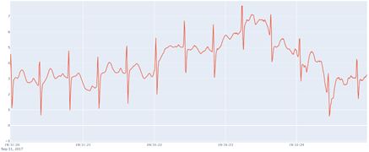

**Figure B2.**

*Raw data after baseline correction()-zoomed in.*

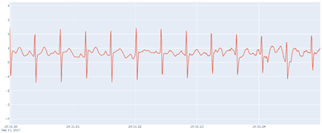

**smooth_signal:** Provides noise correction for low-level background noise. Data provided in list format (or 1-dimensional numpy array) is returned in a 1-dimensional numpy array containing filtered data.

**Figure B3**

*Raw data before smooth_signal()-zoomed in.*

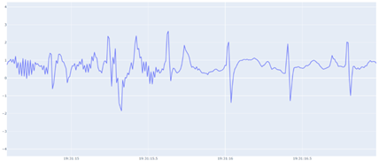

**Figure B4**

*Raw data after smooth_signal()-zoomed in.*

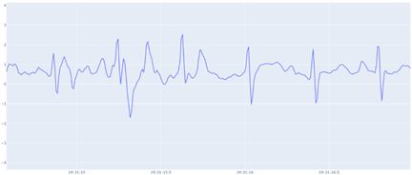

**get_samplerate_datetime:** Calculates the sample_rate for use in HeartPy’s functions.

**Functions by MARS group**

**file_opener:** Takes the user’s input file name and searches the local working directory for a .csv and a .hdr file with the same name. If they are found, they will be opened, read into lists and returned to main, exiting the file_opener(). If a matching .csv and .hdr file are not found, but a .csv file with the same name is present, it will be sent to the cat_file_parse() to determine if there is an .hdr file nested in the .csv file. If there is a .cat file denoting a concatenated file found, it will also be sent to the cat_file_parser(). If the cat_file_parser() finds both the .csv and .hdr file the contents will be returned to the file_opener() which will then package them in a tuple before returning them to main. If the cat_file_parser() does not find file contents, and a matching .csv or .hdr file has not been found it will return a keyword to return to main to exit the main loop causing the program to end.

**cat_file_parser:** Called when there is not a linked .csv and .hdr file found in the directory based on file name, but there is a .csv file present. This function will check to see if there is nested .hdr file information at the beginning of the .csv file present. If there is .hdr file information in the .csv file, it will be parsed from the .csv file. Following, both the .hdr and .csv file contents will be returned to main. If there is not .hdr file information at the beginning of the .csv file, the cat_file_parser() will return a keyword to exit the main loop where the end user can check their files and directory to retry the program again.

**hdr_data:** Data collection from hdr file:

* ‘Label’ data necessary for creating header line in outfile
* ‘Period’ interval recording data (2 ms, 4 ms, etc.) necessary for filling in gaps later
* Count of columns that should exist in csv file for use in filling in blank columns

Currently, all of the data from the hdr file is stored in a nested dictionary, although only some of the data is currently used. The idea was that if other data was needed later on, it would already be readily available. As a memory saving measure, all data from the hdr_dat dictionary is cleared out after necessary data is retrieved.

**Figure B5**

*Electrode data from .hdr file.*

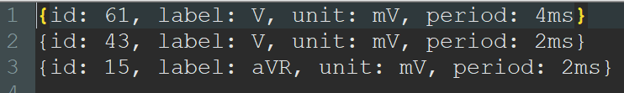

**align_plus_dat:** Compares the number of nodes in the .hdr file to the number of columns at the beginning of the .csv file. The user is alerted that the .csv file is not aligned, the number of missing columns that need to be filled in is recorded, and the ‘label’ values from the .hdr file become the keys for the dictionary that will contain the data from the .csv file.

**time_out:** Collects all data line by line (into ‘file_dat’ dictionary) while:

* Generating missing timestamp data and generating time gap notification
* Filling in blank columns with baseline values
* Filling in interval recording gaps to convert all data to 2 ms interval, capable of filling in any gap of **any** interval

This is the main function of the entire program. The first minor hurdle of the program was to fill in the missing timestamp data since in the original .csv file, the datetime values were only provided every 2,560 lines (5,120 ms). This was accomplished by adding 2 ms to recorded datetime from the previous line. When the program encounters a provided datetime that doesn’t fit (i.e. is not 2 ms after the previous line’s datetime), it is assumed that there is a time gap that may have occurred if the ECG machine was disconnected for a short period of time. The program notifies the user of the time gap and its duration, and adds in new lines that contain the missing datetime values from the time gap with blank, baseline values (assumed to be 0.5) for each node.

For any nodes with a regular timer interval of 2 ms, a baseline value was inserted if there were any periods with null data. For nodes that have a longer interval (4 ms, 8 ms, 16 ms, etc.), the program automatically detects and fills in the gap taking an average of the data before and after the interval gap and filling in the values. As expected, nodes with longer time recording intervals (over 12 ms) end up having slightly inaccurate graphs.

**new_folder:** prints the user’s chosen dataset (unaltered or corrected data pulled from the original .csv file and stored within a dictionary) to a .csv outfile with header line data pulled from the .hdr file.

**corrected_dict:** This is where all the data correction functions above are applied to each dataset. First, get_samplerate_datetime() is run to obtain the sample_rate specific for each dataset. Then, correction functions are applied in the following order:

1. flat_peak_reduct()
2. remove_baseline_wander()
3. tall_peak_reduct()
4. smooth_signal()

Data enters as a list and is returned in a 1-dimensional numpy array nestled within a tuple. We stored the data in a tuple as a space saving measure.

**flat_peak_reduct:** Performs two main functions:

1. Reduces long, flat peaks that are over 20 ms long. This detects segments of identical, repeated values sustained for more than 10 data points (10 x 2 ms = 20 ms) and reduces them down to the baseline (assumed to be 0.5). This is run before the baseline correction filter in the corrected_dict() function to help reduce issues we found with some data sets that had impossibly tall flat peaks. Only running the baseline correction without accounting for these data anomalies would cause the entire baseline of our graphs to curve sharply. Initially, the program assumed that these were very tall heartbeats and curved the entire graph to fit them into an expected baseline (see example below). Flattening these flat “peaks” down to the baseline corrected this error.

**Figure B6**

*Baseline correction before flat_peak_reduct.()*

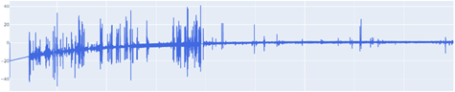

**Figure B7**

*Baseline correction after the older version of flat_peak_reduct()*

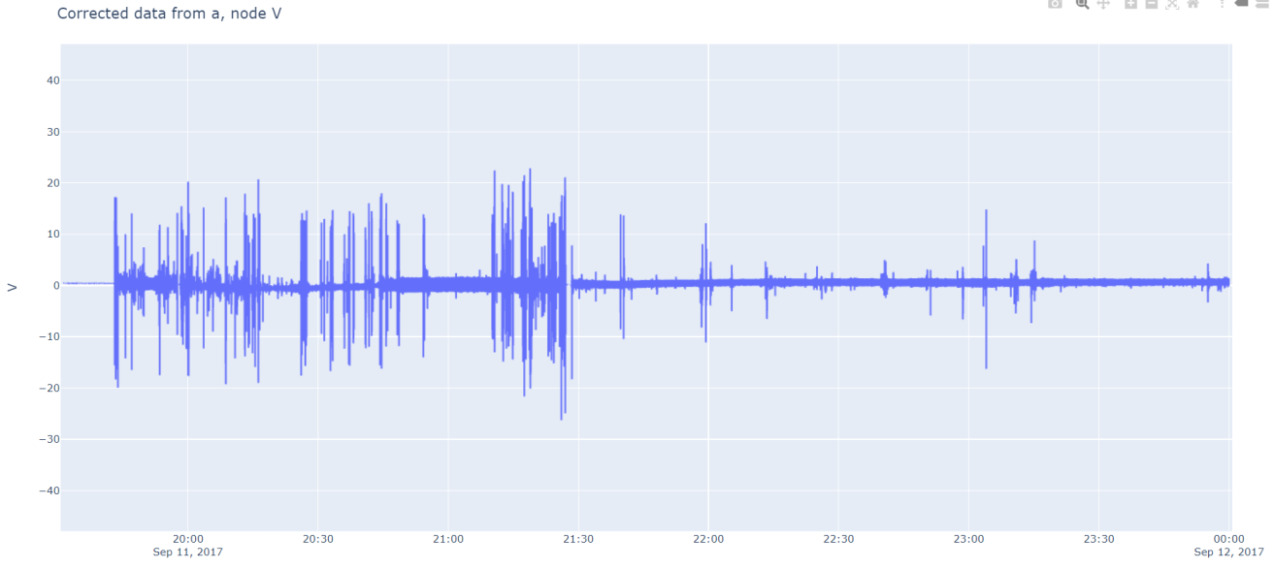

*Note*: this does not include the newer sub-function below.

1. Reduces tall, steep peaks that are outside of the normal capabilities of the human heart. This detects peaks that have a slope that is too steep and a peak that is too tall. This is also run before baseline correction to avoid issues with baseline correction causing a curved graph because of impossibly tall peaks. It is also run concurrently with the first part of flat_peak_reduc() to avoid iterating through the data multiple times when it is not necessary, to speed up processing time.

**Figure B8**

*Unaltered data before flat_peak_reduct()-zoomed in.*

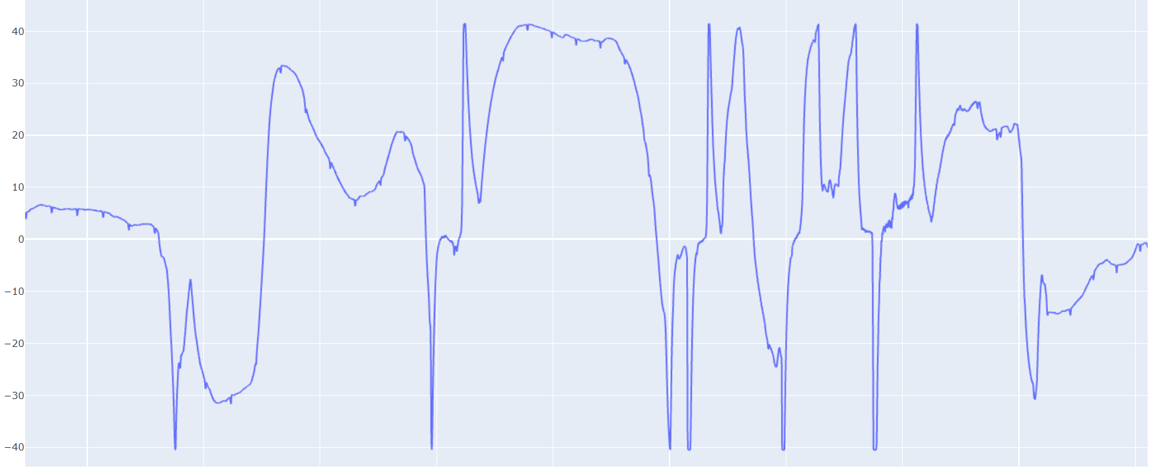

**Figure B9**

*Data after only running flat_peak_reduct()-zoomed in.* 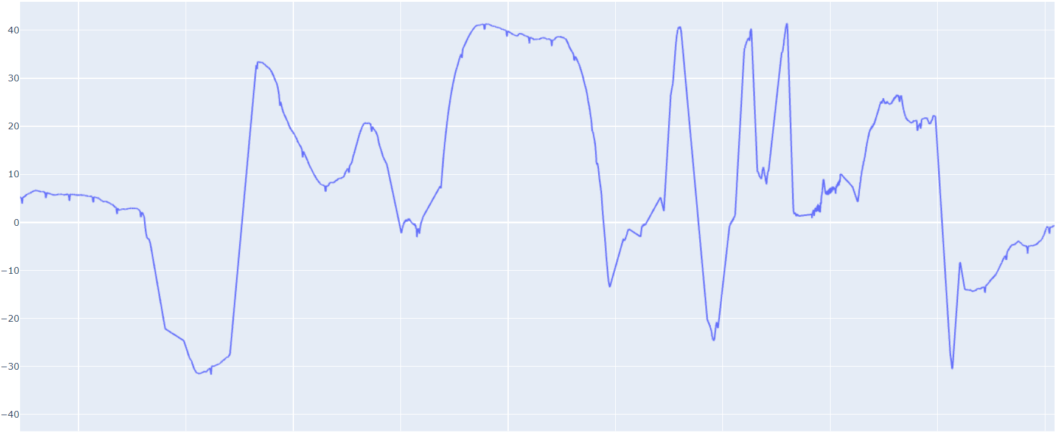

**tall_peak_reduct:** A function nearly identical to the second part of flat_peak_reduct(). This is run after baseline correction to clean up any other impossibly tall peaks that may have been created in the baseline correction process.

**Figure B10**

*Data after flat_peak_reduct() and baseline correction only.*

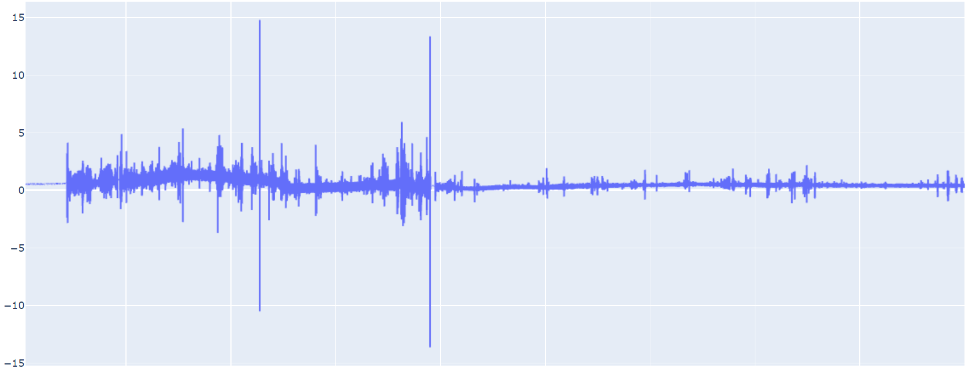

**Figure B11**

*Data after flat_peak_reduct(), baseline correction, and tall_peak_reduct().*

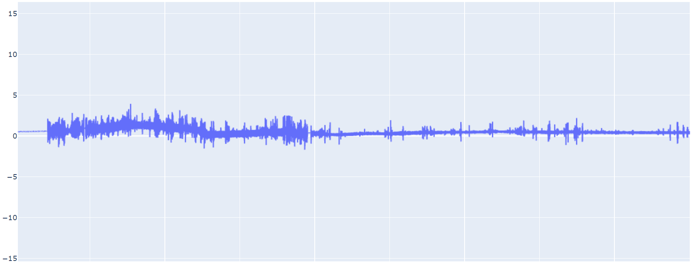

**print_dict:** Prints the chosen dictionary (unaltered or corrected data) to a .csv outfile with header line (‘label’ data from .hdr file) in similar format to original .csv file.

**Appendix C**

Contents of Files Needed for Dash Application Deployment

**1) Procfile [NO extension]**

web: gunicorn app:server --log-file=-

**2) runtime.txt**

python-3.7.10

**3) requirements.txt**

Brotli==1.0.9

certifi==2020.12.5

chardet==3.0.4

click==7.1.2

dash==1.19.0

dash-bootstrap-components==0.11.3

dash-core-components==1.15.0

dash-html-components==1.1.2

dash-renderer==1.9.0

dash-table==4.11.2

dask==2.17.2

DateTime==4.3

Django==3.1.7

django-heroku==0.3.1

Flask==1.1.2

Flask-Compress==1.9.0

future==0.18.2

gunicorn==20.0.4

h5py==2.10.0

HeapDict==1.0.1

heartpy==1.2.6

html5lib==1.0.1

idna==2.9

itsdangerous==1.1.0

Jinja2==2.11.2

json5==0.9.4

jsonschema==3.2.0

MarkupSafe==1.1.1

plotly==4.14.3

python-dateutil==2.8.1

python-jsonrpc-server==0.3.4

python-language-server==0.31.10

requests==2.24.0

retrying==1.3.3

six==1.15.0

urllib3==1.25.9

Werkzeug==1.0.1

numpy==1.18.1

scipy==1.4.1

**4) .gitignore**

**\*This file does not appear to be in the project directory, as the ‘.’ marks it as a hidden file**

venv

*.pyc

.DS_Store

.env

**Uses**

These programs are designed specifically for Nationwide Children's Hospital (NCH). They are built to view ECG output files (.csv and .hdr) and to convert the respective data to MIT format (.hea and .dat).

**Heart Rate Viewer in Python (HRVY)**

Find the full code at <https://github.com/mars-group-2021/mars-hrvy>

**Capabilities**

1. Fills in missing data
   1. User has the option to use the modified data or original data to proceed
2. Projects ECG graphs to the screen.
   1. User can zoom in and scroll through the data

**Directions**

1. Load the libraries: Ensure the libraries for scipy, numpy, heartpy, plotly, and plotly.express are installed on the local machine.
   1. Go to the computer’s command line prompt and type in:
      1. >pip install numpy
      2. >pip install heartpy
      3. >pip install scipy
      4. >pip install plotly
      5. >pip install plotly.express
2. Run the program: The team recommends utilizing the file manager of your local system as the standard method for running HRVY. However, there are alternative methods to running the program’s script, though they can become complicated and overwhelming to some. The next best direct method, that does not require any additional program or integrated development environment (IDE) downloads, would be through utilizing the command line. Additionally, we have provided advanced methods for running HRVY, though we suggest they should be utilized as the last option.
   1. Through your system’s local file manager:
      1. Linux/Unix: Open your system’s file manager and locate hrvy.py to make sure the .csv and .hdr files are located in the same folder, and then double click hrvy.py.

*\*\* This will only work if the hrvy.py file has execution permissions. This can be accomplished by entering:*

> chmod --x hrvy.py on the command line.

Or on a Linux system with a graphical user interface such as Ubuntu, select hrvy.py and right-click to see a pop-up menu, then scroll down to Properties. Next, select Permissions and then click the Execute box to allow hrvy.py to run as a program, as shown in Figure D1.

**Figure D1**

*Changing hrvy.py permissions in Ubuntu.*

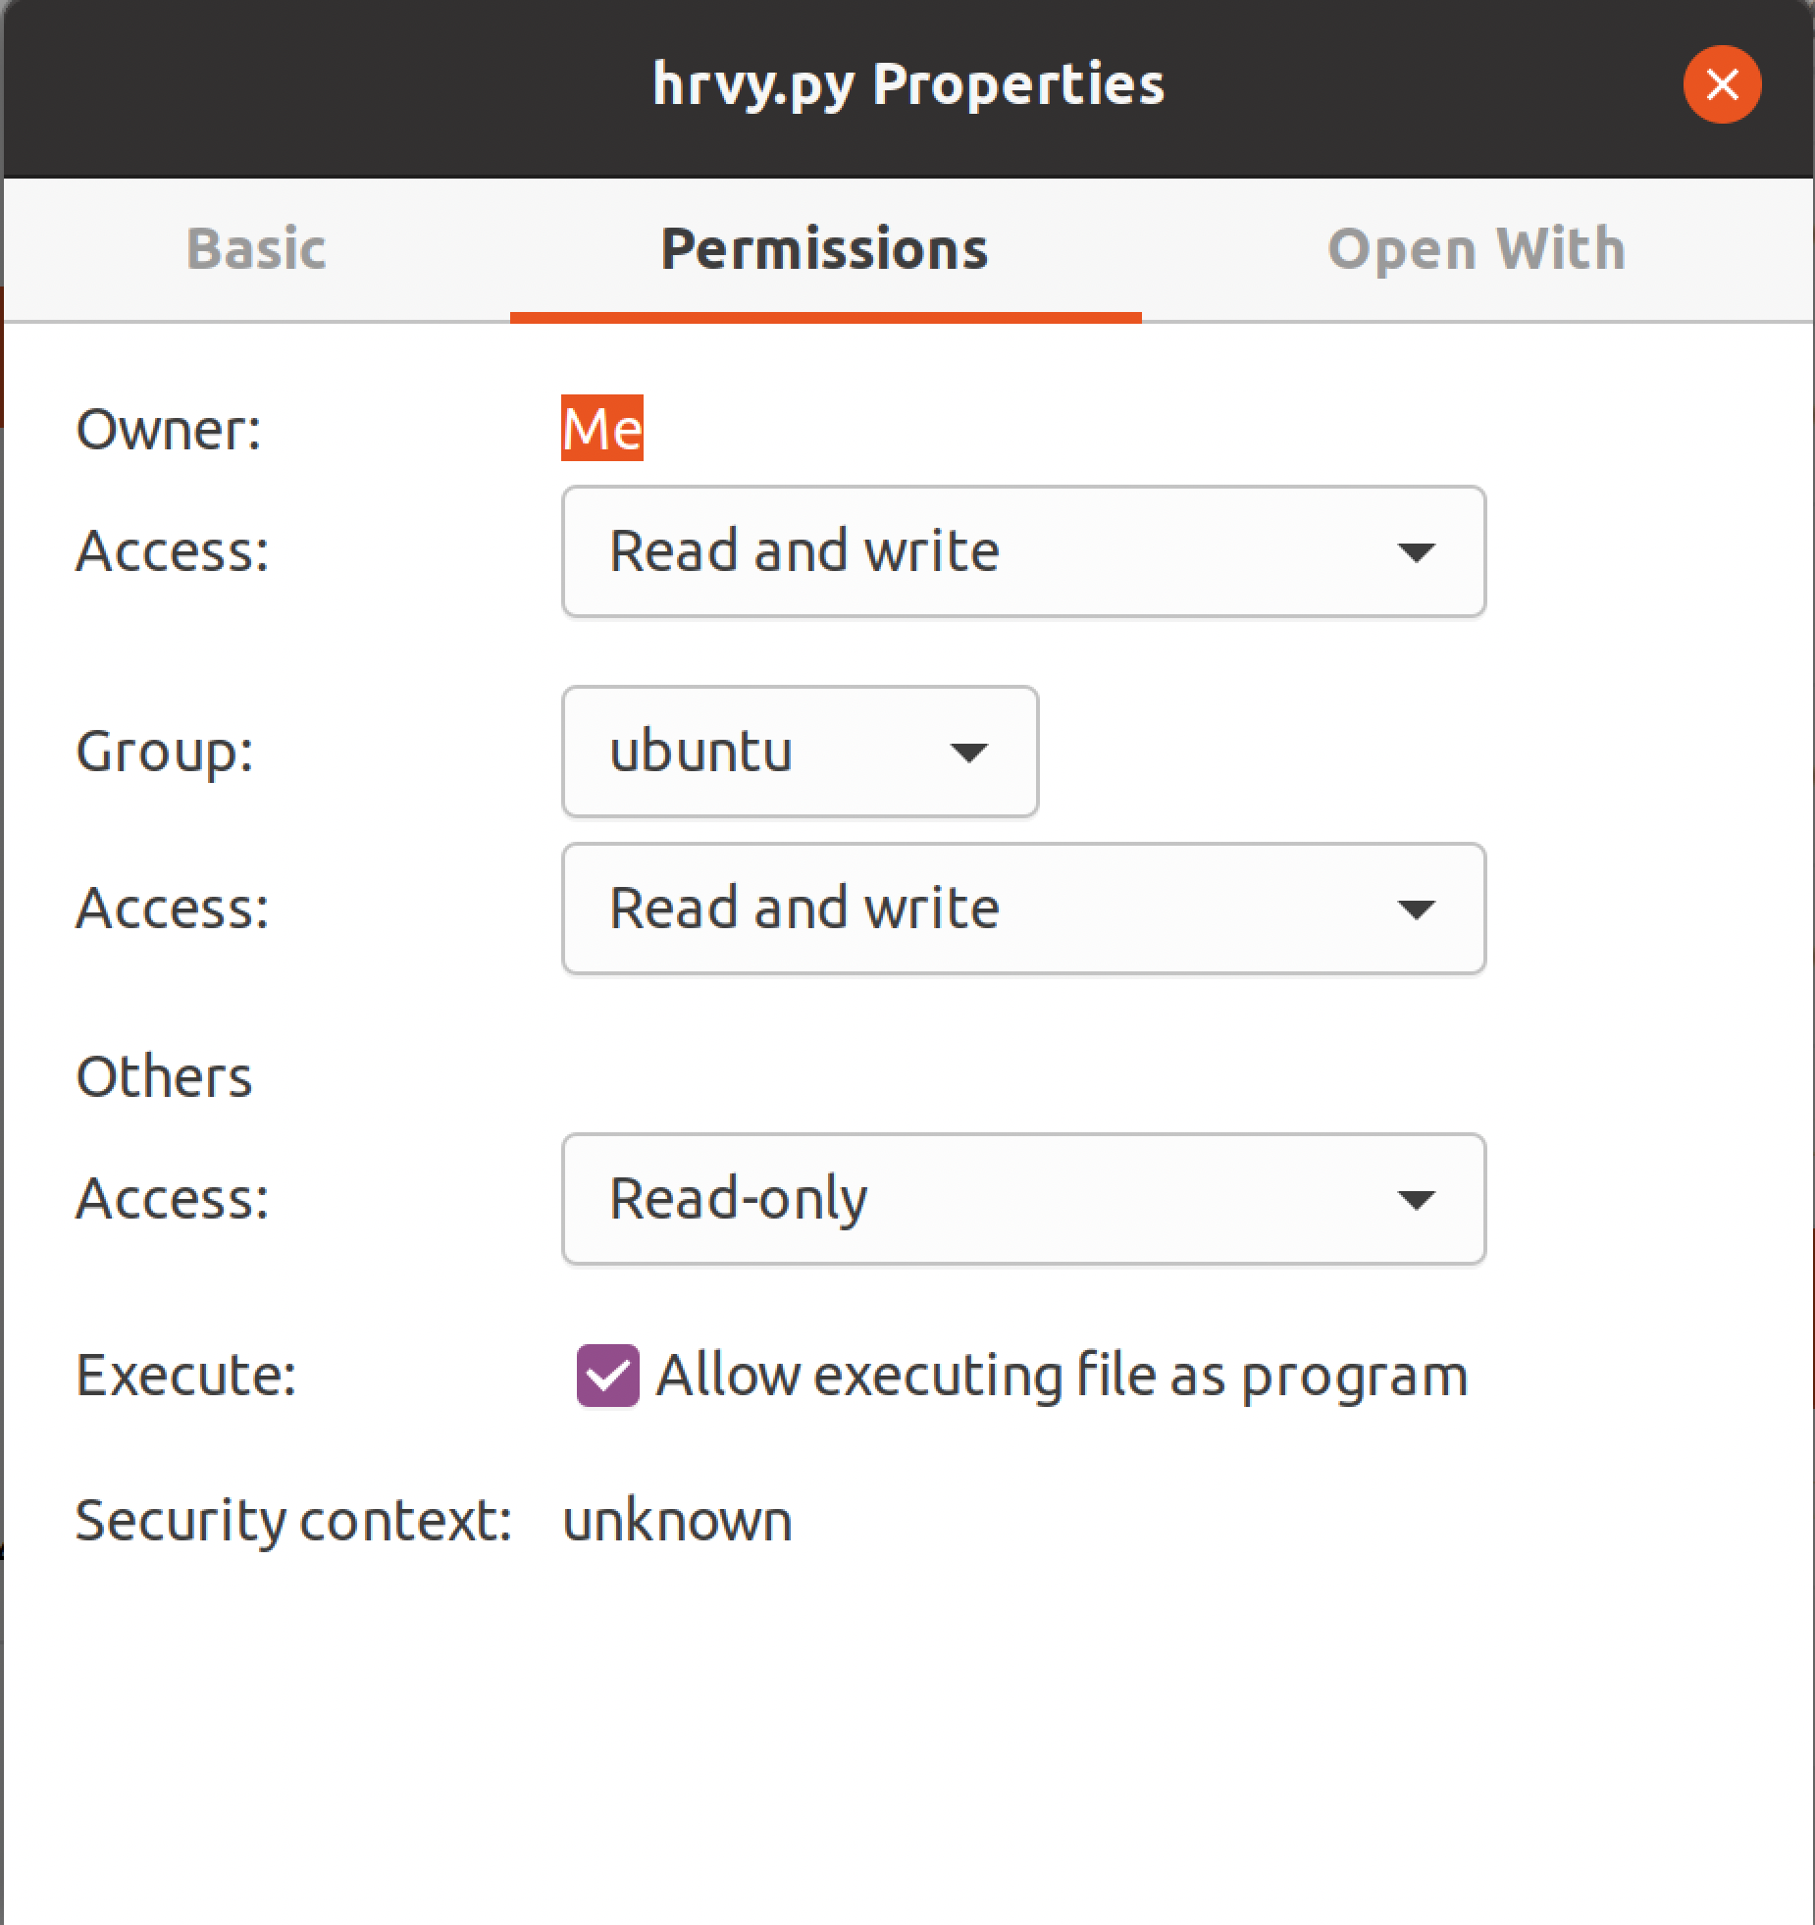

Alternatively, you can select Open With and then choose the Python development environment you want to run hrvy.py under, as shown in Figure D2 .

***Figure D2***

*Selecting hrvy.py’s development environment in Ubuntu.*

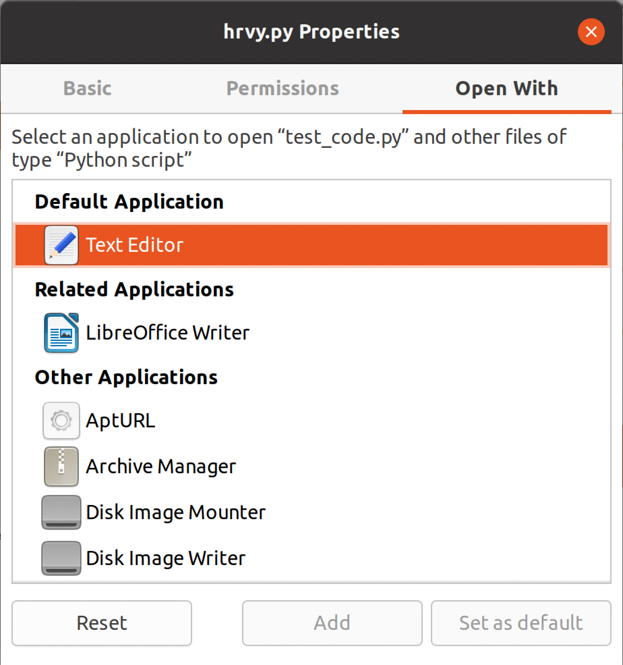

* + 1. WindowsOS: Open the file manager to locate the program’s script, hrvy.py. Double check to make sure the .csv and .hdr files are located in the same folder. If they are, proceed to double click hrvy.py.
    2. MacOS: Open a Finder window to navigate to the directory of the program’s script, hrvy.py. Double check to make sure the .csv and .hdr files are located in the same folder. Next, select hrvy.py and either right-click to select Get Info from the pop-up menu, or go to the main menu bar at the top of the screen and select Finder → File → Get Info. Then, under the “Open with” option, select the application you use typically to run .py files (as shown in Figure D3). Click the Get Info window closed, and then double-click the hrvy.py file to enter your Python development environment and run the file. (Note: you may also follow the Linux instructions in (i) above by opening a Terminal window.)

**Figure D3**

*hrvy.py’s Get Info window in macOS.*

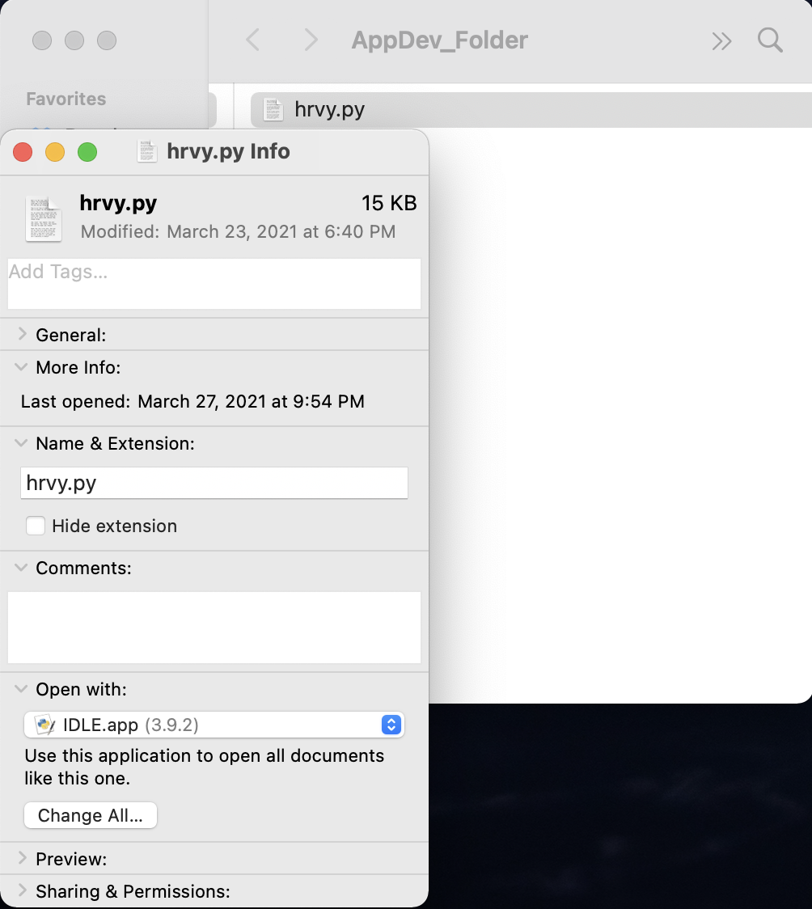

* 1. From the command-line enter:
     1. Open the command prompt, make sure you are in the correct directory where hrvy.py and the .csv and .hdr files are located.
        1. If you need to change the directory in a Linux system enter:
           1. > cd [insert the full path]
        2. If you need to change the directory in a Windows system enter:
           1. > cd [insert the full path]
        3. If you need to change the directory in a Windows system enter:
           1. > cd [insert the full path]
     2. Once the files are in the set working directory, enter:
        1. > hrvy.py
  2. With Python’s IDE IDLE:
     1. Locate and open IDLE in your system.
     2. If you are unsure of the current working directory IDLE is using enter:
        1. >>> import os
        2. >>> os.getcwd()
     3. If this is not the directory where the .hdr and .csv files that you are planning to run are located, and you would like to change IDLE’s working directory to that folder, enter:
        1. >>> os.chdir(“[insert full path]”)

*\*\* If you do not know the full path to the folder, open the folder and right click on any file, then select properties. Find location and copy the path. Paste the path into the code but before pushing enter, make sure to change every instance of the backslash ( \ ) to a forward slash ( / ) or you will receive an error. If there are no files in the directory folder, open the folder with the File Manager and right click on the address bar to copy the path. The backslash will still need to be adjusted.*

* + 1. Make sure hrvy.py script is also in the directory folder along with the .hdr and .csv files.
    2. From the IDLE window, click on File then go to Open and click on the hrvy.py.
    3. The entire script will then open in a new window, press F5 to run the script or go to the Run tab and select Run Module

*\*\* If you receive a module error for missing packages, return to step 1 and reload the packages through the command line.*

1. Enter requested input:
   1. The program will prompt you to enter the file name or the name of the data set, it is expected to be the same for both the .hdr and .csv files. Only the data set name without any file extension is required.

*\*\*If both .hdr and .csv file contents are not found for the dataset, including in a concatenated file, the program will prompt you to double check the file name and directory, and then end.*

* 1. You will then be prompted to select the filtering method to be used in this run of the program. You are only required to enter the number
  2. Following this, you will be asked if you would like the data printed to a file in a local folder, you will have been notified if a new folder for the dataset’s data has been generated. If it has, this is where the graphs and files can be found.

**Troubleshooting**

1. Ensure the *file_name.csv* and *file_name.hd*r files are located in the same directory/folder as hrvy.py.
2. Make sure these open-source modules have been updated to their latest versions: HeartPy, Plotly, Numpy, and SciPy.
3. Depending on the size of the dataset, your browser may have difficulties displaying the signal plot. Be sure to clear your browser’s cache prior to loading a plot.

**Known Issues**

1. In macOS Big Sur, the filename of the output plot is not written specifically, and contains the prefix “file:///Users/. . .”. This does not affect the plot display.

**Heart Rate Processor in Python (HRPY)**

Find the full code at <https://github.com/mars-group-2021/mars-hrpy>

**Capabilities**

1. Fills in missing data in ECG files
2. Extracts information from the .csv and .hdr files
3. Converts the data found in the .csv file to MIT format
4. Outputs:
   1. Modified .csv file with gaps filled in
      1. The program fills in gaps by using the average of the last known value and the next known value
   2. Header (.hea) and binary data file (.dat)
5. The output files should be readable by the DOS mystery converter

**Directions**

1. Ensure the WFDB library is installed.
   1. Go to the computer’s command line prompt and type in:
      1. >pip install wfdb
2. In the command prompt, navigate to the folder where the program is located.
3. Run the program by typing in the following:
   1. >python hrpy_v1.py <hdr_filename.hdr> <csv_filename.csv>
      1. NOTE: if the .hdr and .csv files are not located in the same directory as the program, the file path will need to be included.
   2. There is no need to concatenate the .hdr and .csv files before running the program.
   3. The program will parse out information from the files and does not require further user input.
   4. IDs from the hdr file are used as the signal IDs.
4. The program will deliver the following outputs:
   1. Modified .csv file
      1. Any data gaps will be filled in using the average of the last valid value and next valid value.
      2. This file is for your own information and does not need to be kept
      3. This will be saved in the same directory as the Python program and will be named as follows:
         1. csv_filename_new.csv
         2. For example if your original file name was “PT843.csv” the modified file would be “PT843_new.csv”
   2. Header file (.hea)
      1. This will be saved in the same directory as the Python program and will be named as follows:
         1. csv_filename_new.hea
      2. The record line:
         1. Name of the input file, the number of signals, the sampling frequency (number of samples per second), number of samples per signal, the base time and the base date.
      3. Signal specific lines:
         1. The output file name, the storage format of the data, the ADC gain, the baseline ADC units, the units of the signal, the ADC resolution, the ADC zero, initial value, checksum, block size, and description (in our case, it is the column header/ID number).
         2. Refer to the Definitions table (D1) for information on these.
   3. Data file (.dat)
      1. This will be saved in the same directory as the python program and will be named as follows:
         1. csv_filename_new.dat
      2. This is binary and will not be viewable

**Troubleshooting**

1. Ensure the WFDB library is installed and up-to-date.
   1. The program requires at least version 3.3.0 to be installed.
      1. >pip install wfbd==3.3.0
2. Consider updating Python to version 3.9.x and use pip3 for package installation
   1. Using pip3 will ensure that all packages will be installed in Python3 (using pip will use the first Python version listed in your system PATH variable).
3. Ensure the .csv file is is the format shown in Figure D4

***Figure D4***

*Appropriate input .csv file format*

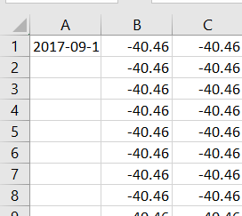

*Note*: Date and time are in the upper left cell. All data is contained in columns to the right of the date- time cell.

**Process Flows**

**HRVY**

***Global Variables List***

* str ( dataset ): file name
* tuple ( contents ) : A tuple of lists used to shuttle returned the .hdr & .csv file contents from the **file_opener**
* list ( hdr ): the .hdr file contents read into a list
* list ( csv ) : the .csv file contents read into a list
* tuple ( hdr_info ): A tuple of a dictionary and a list used to shuttle the hdr dictionary and the nodes_not_2ms list back to main
* dictionary ( hdr_dat ): data dictionary with hdr contents
* list ( nodes_not_2ms ) : recording the node information from non-2 ms intervals
* tuple ( dat_align ): A tuple of a tuples and a dictionary used to return the tuple align_content and the dictionary file_dat back to main
* dictionary ( file_dat ): the working data dictionary
* dictionary ( final_dat ): The final adjusted file data to be graphed with plotly and where the user will have printing options presented

***Current Functions & Variable List ( in Order of Process Flow )***

* file_opener( dataset )
  + Utility: Used to find and open .hdr, .csv, and .cat files from within the user’s current working directory
  + Input: dataset or the name of the file
  + Return: contents (hdr and csv) the .hdr and .csv files read into separate lists or the keyword ‘end’ used to exit the main loop and end the program
  + Process:
    - Begins: The user’s current working directory is accessed and each file is searched for approved extensions with the given dataset name.
    - The first loop of the if statement will check for a .csv extension with the matching dataset name. If one is found, the nested iteration of second_file checks the current directory for a matching dataset with an .hdr file extension.
      * If one is found, both the files will be opened using ‘open with’. By using this method, an execution block is created. This results in an ‘opening’ object getting assigned to the file, ensuring the object will be destroyed and the file closed when the block is complete. Following this, the .hdr and .csv file contents are read into a list with the respective titles and hdr_found is set to True.
        + If there is no matching .hdr file in the directory, hdr_found will still be set to False. The **cat_file_parser** will then be called to check for hidden .hdr file data in the .csv file. If the **cat_file_parser** returns with no hdr data, the loop will continue checking the directory for the next extension.
    - If a .cat file is found in the directory with the correct dataset name, the **cat_file_parser** will be called. It will return with either a tuple titled contents with the .hdr and .csv file content read in as separate lists, or it will return with the keyword ‘end’ to exit the main function loop, if no concatenated file is found.
    - Regardless of what is found in **file_opener**, contents will get returned at the end of the function, if no .csv and .hdr file data has been found meeting the requirements, contents will be returned with ‘end’ to exit to loop in the program’s main. If the files have been found, they will be returned in the tuple.
    - Variables:
      * boolean ( hdr_found ): to check for a matching .hdr and .csv file
      * str ( file ): each file in the user’s current working directory
      * str ( second_file ): searching the user’s current working directory for a nested iteration
      * str ( cur_dir ): the path to the user’s current working directory
      * str ( dataset ): the data set name or file name
      * file object ( h ): value assigned to open the .hdr file
      * file object ( v ): value assigned to open the .csv file
      * tuple or str ( contents): the value to be returned from the function. It will either return as a tuple with two lists from the .hdr and .csv file contents or it will be returned as a string with the keyword ‘end’ that will exit the main loop, print ‘not found’, and end the program.
* cat_file_parser( cat_file )
  + Utility: Used to separate .hdr file contents from a .csv file when nested or concatenated
  + Input: .cat file- a concatenated .hdr and .csv file or a single .csv file
  + Return: contents_tup a tuple with the .hdr and .csv file contents, the .csv file is named intro until it is returned
  + Process:
    - Begins: The boolean value check and a list called hdr are initialized. Additionally, an integer variable, del_num that will identify how many lines need to be deleted from the .csv file contents to completely remove the .hdr file contents before returning the two separate file lists. The cat_file is opened and read line by line into a list titled intro.
    - Every line in the cat_file is checked to see if the line starts with the beginning characters of the .hdr file ('{id:').
      * If they do, then each line that starts with characters will be added to the hdr list. At the same time, one is added to the value of del_num, which starts at zero. This is to keep track of how many lines need to be removed to completely separate the .hdr and .csv file contents.
      * If the line does not start with the beginning characters of the .hdr file ('{id:'), and there have no been any line found beginning with those characters, resulting in del_num remaining at zero, then no file is found, the user will be notified and the function exited.
      * If there is a value for del_num and a hidden .hdr file was found, for the value j in a range starting at 0 and ending at the line number, the cat_file currently named intro will remove a line from the list specified at the index value zero to account for removing the .hdr file contents. Zero is used as the line numbers are shifting back down each iteration with deleting the line, so the first item in the list will always have been the next item. Now, intro has become a complete .csv file and both the .hdr and .csv file lists can be returned
    - hdr and intro are packed into a tuple called contents_tup and returned to **file_opener** where they will then be returned to main.
  + Variables:
    - int ( del_num ): an integer counter to keep track of the number of lines need to be deleted from the cat_file at the end of the function
    - list ( hdr ): holds each line of the hdr file per index position
    - object ( f ): variable where the open file object is assigned
    - list ( intro ): where all of the .csv file contents from cat_file are saved
    - int ( i ): value assigned to count through the iteration of intro
    - int ( j ): value assigned to count through the iteration of del_num
    - tuple ( contents_tup ): where hdr and intro will be returned to **file_opener**
* hdr_data( hdr )
  + Utility: Writes the hdr file contents into a nested data dictionary
  + Input: hdr list with the .hdr file contents
  + Return: hdr_info a tuple of dictionaries holding the hdr data in hdr_dat and node_not_2ms where intervals that are not 2 ms have been saved
  + Process:
    - Begins: Two different dictionaries are intialized, they are titled hdr_dat and node_not_2ms. An integer variable titled node is assigned the value of one. It depicts the starting point for the node count to keep track of the total nodes present in the data set.
    - Each index position of the hdr list represents a line of data from the original .hdr file. Everyone of these lines will be processed for reformatting to be conducive to string manipulation in Python. Every line of the hdr list will have all newline symbols and the opening and closing brackets removed. Additionally, each individual line will be further separated at every instance of the comma. This sends all the individual values into another list called l_split.
      * While still on the same iteration of the line of the hdr index, a new nested dictionary is initialized within hdr_dat where the node information is utilized as a key for each line of values from the original .hdr file.
        + The values for each node key in l_split will be processed. Starting with the first value at index 0, all the colons will be removed and the string will be split at the space. This will then become a key in the nested hdr_dat dictionary. The item at the next index position will become the value for that key.

If this item at position 0 has a string for the time ‘period’ instead of a colon and the item at index 1, which will be the value for the key, is not 2 ms then the key and value pair will also be added to the nodes_not_2ms dictionary where it will be reformatted similarly. The time interval will now be the key in the nodes_not_2ms library and the current node count is the value for that key.

* + - * + Following this, the node count will increase with each line in the hdr list, mirroring the .hdr file, that is processed.
  + Variables:
    - dictionary ( hdr_dat [ node ] ): holds the node specifications listed in the original .hdr file
    - int ( node ): number of nodes in the hdr file
    - list ( node_not_2ms ): alternate node recording time interval
    - int ( line ): value assigned to access each index position of the hdr list
    - list ( l_split ): ID, label, unit, time period info from nodes in the hdr file
    - int ( item ): value assigned to access each index position of the l_split list
    - tuple ( hdr_info ): returns the hdr_dat dictionary and the nodes_not_2ms list back to main
* align_plus_dat( hdr_dat, csv )
  + Utility: Checks the alignment of the .csv file information and generates file_dat dictionary
  + Input: hdr_dat dictionary and csv list
  + Returns: dat_plus_align a nested tuple the file_dat dictionary and the align_contents tuple holding one string and many integer variables utilized in **time_out**
  + Process:
    - Begins: An empty string variable titled aligned is initialized, and the length of the hdr_dat dictionary is assigned to num_nodes.
    - The first item in the csv list is separated at the comma into a nested list and the length is taken. This determines how many recording nodes have contributed to the data in the file, this is assigned to num_cols_start.
    - To find the total number of missing nodes, or columns of missing data represented by num_cols_mi, num_nodes has one add to it to offset the 0-index of Python. Then num_cols_start is subtracted from it.
    - If there are not any missing columns in the data, aligned will be set to yes. If there are missing columns that will later need to be filled in, aligned is set to no. The user receives a print out updating them of the alignment status.
    - The file_dat dictionary is then initialized where the is set to the time.
      * Every key in the hdr_dat dictionary is checked to see if it has a label value where it is added to the file_dat dictionary as a key.
    - The hdr_dat dictionary is then cleared and num_nodes, num_cols_start, num_cols_mis, and aligned are packed into a tuple titled align_contents.
    - The align_contents tuple is then packed into another tuple titled dat_plus_align with the file_dat dictionary to be returned to main.
  + Variables:
    - str ( aligned ): identifies if missing data will need to be generated in **time_out**
    - int ( num_nodes ): the number of nodes present in the .hdr file
    - int ( num_cols_start ): the starting number of columns in the .csv file
    - int ( num_cols_mis ): the number of missing columns from the .csv file
    - dictionary ( file_dat ): initialized with the keys for csv data entry occurring in **time_out**
    - tuple ( align_contents ): holds num_nodes, num_cols_start, num_cols_mis, and aligned
    - tuple ( dat_plus_align ): returns align_contents and file_dat back to main
* time_out( csv, file_dat, nodes_not_2ms, align_cont )
  + Utility: Checks for time gap
  + Input: the csv list of data points, the file_dat dictionary with only keys, the nodes_not_2ms list with the alternate time inveterals, and the align_cont tuple with the column and node information
  + Return: file_dat dictionary
  + Process:
    - Begins: The datetime package is imported and assigned an alias at the beginning of the function.
    - The align_contents tuple is unpacked, restoring the integer values num_nodes, num_cols_start, num_cols_mis, and the string aligned from **align_plus_dat**.
    - An empty string titled last_line_time is initialized and two_ms is set to 2 ms from dt.
    - Each line from the .csv file in the csv list is checked to see if it doesn’t have a comma at the beginning, if it does, then the timestamp is formatted and assigned to curr_line_time, it is then checked for the standard 2 ms time gap.
      * If the time gap is not 2 ms and it is less than a minute away from the last time stamp, the user will be notified of the time gap in seconds. If the gap is more than a minute the user will be notified of the gap in minutes.
        + The file_dat dictionary then has the data from the line read in as values paired to a key for the time intervals. If there is a missing time, 0.5 is added to the value as a baseline substitution.
        + The user is notified when the missing values are filled and last_line_time is adjusted to reflect what should be accurate for the next iteration.
      * Following this, if the dataset was missing any data points they are filled in with the baseline. If there are missing nodes, or empty columns, they are filled in.
      * If there are nodes that are not the standard 2 ms interval, the time gap or interval is filled in to account for every 2 ms based on the average of the last known values
  + Variables:
    - alias ( dt ): an alias reference for the datetime module
    - tuple ( align_contents ): holds values identified in **align_plus_dat**
    - int ( num_nodes ): the number of nodes present in the .hdr file
    - int ( num_cols_start ): the starting number of columns in the .csv file
    - int ( num_cols_mis ): the number of missing columns from the .csv file
    - str ( aligned ): identifies if missing data will need to be generated
    - dictionary ( file_dat ): begins with keys and has values generated from the .csv file data
    - str ( last_line_time ): the time recorded from the last iteration and line in the .csv file
    - time ( two_ms ): instance of timedelta from the datetime module
    - list ( csv ) : the .csv file contents read into a list
    - int ( line ): value assigned to access each index position of the csv list
    - time ( curr_line_time ): the time recorded for the current iteration and line in the .csv file
    - time ( time_dif ): the calculated time difference between the current .csv file line and the previous one
    - int ( n ): value assigned to count through the iteration of num_cols_start
    - int ( interval ): value assigned to access the non-2 ms time gap
    - list ( node_list ): all of the node details temporarily stored
    - int ( min_start ): the last known value
    - int ( empty_vals ): the values to be filled
    - int ( mis_val_int ): the last known value
    - int ( mult ): used for computing the average
* plot_out( file_dat, dataset )
  + Utility: Presents the user with data processing and printing options, then plots the data
  + Input: file_dat the completed data dictionary and the dataset name
  + Return: - no variables returned to main, an offline Plotly chart is saved locally
  + Process:
    - Begins: The Plotly packages needed for graphing are imported at the beginning of the function and the user is presented with filtering options.
      * If the user selects the unaltered data, the final_dat dictionary will be set to data_pref, and the title will be set accordingly
      * If the user chooses the baseline correction and noise reduction, the data dictionary, final_dat, will be processed through **corrected_dict**. The new filtered data dictionary will return from **corrected_dict** as corrected. With the corrected data set to data_pref, the final_dat dictionary is no longer needed so it is emptied to save memory and the title is set.
    - Following this, the user will be presented with the option to save the completed data locally for printing.
    - The final data stored in data_pref is now accessed by the key and utilized to set the Plotly figure specifications. The Plotly graphs are then saved locally for offline viewing and data_pref is emptied.
  + Variables:
    - int ( opt1 ): user input for processing selection
    - dictionary ( data_pref ): the dictionary used for plotting
    - dictionary ( corrected ): the dictionary returned from **corrected_dict**
    - str ( title ): title for the plot according to data selection
    - str ( opt2 ): user input for printing selection
    - file object ( out ): value assigned to open the .csv output file being written at the user’s request
    - str ( key ): references the dictionary keys
    - figure ( fig ): the specifications for a Plotly graph
* new_folder( )
  + Utility: Used to create a local folder where the processed data from the data set and the completed graphs will be stored
    - Called from **plot_out**
  + Input: - no input required
  + Return: - no true return variables within the program, a new folder is created
  + Process:
    - Begins: With the os package standard to base Python, the path of the current working directory on the local machine is accessed and the dataset or the file name is added to the end of the path.
    - In the try block, the folder is created unless there is an error throw by the operating system.
      * If the folder is successfully created, the program will let the end user know through an output message. The current working directory of the program will then be changed to the new folder before exiting the function.
      * If an error has been thrown, the end user will receive a message being notified it was not created.
  + Variables:
    - str( path ): the local path to the current working directory with the dataset name added onto the end
    - str( dataset ): the data set or file name used to title the new folder
* corrected_dict( dictionary )
  + Utility: Generates a dictionary of the data that has been filtered with some of HeartPy’s functions, **flat_peak_reduc**, and **tall_peak_reduct**
    - Called from **plot_out**
  + Input: final_dat dictionary with final version of the file_dat
  + Return: corrected a dictionary of the final corrected data that will be used for plotting
  + Process:
    - Begins: A dictionary titled corrected is initialized, the dictionary keys are searched for time labels, where they are added to the corrected dictionary and packed into a tuple. Everything else is a time data value and packed into a tuple that is called by a list of nested functions for filtering and processing the raw data. The corrected data dictionary is returned to **plot_out** for graphing
  + Variables:
    - dictionary ( corrected ): the data that has been processed and filtered
    - str ( key ): references the dictionary keys
    - int ( sample_rate ): sample rate used in remove_**baseline_wander**
* flat_peak_reduct( lst )
  + Utility: Reduces long flat segments to baseline
    - Called from **corrected_dict**
  + Input: lst represents the uncorrected data
  + Return: lst represents the corrected data
  + Process:
    - Begins: Several variables are initialized, if the segment has started and the value is not at baseline, the first and last instance of repeated values are identified and stored as rv_start and rv_end. If the repeated values are longer than 20 ms, they are replaced with baseline and added back to the data list, lst.
    - Following this, the slope of segments are determined based on value and index, the first of each are recorded as i_start and v_start. The slope is checked to determine if the slope for the segment ss1 is in a reasonable range. If not they are not in what is considered a normal range, they are adjusted. Values are also checked for additional extreme outliers.
  + Variables:
    - list ( lst ): where the data originates and returns to, used in intermediate steps as storage
    - object ( rep_val ): intermediate of repeated value
    - float ( steep_slope ): value to be considered steep
    - float ( not_flat ): baseline value
    - object ( i_start ): starting index of the segment under analysis
    - object (i_end ): last index of the segment under analysis
    - object ( v_start ): starting value of the segment under analysis
    - object ( v_end ): last value of the segment under analysis
    - str ( ss_check1 ): segment slope check- Y/N
    - str ( ss_check2 ): segment slope check- Y/N
    - int ( scale_max ): maximum value for the scale
    - int ( ss1 ): slope standard for segment
    - int ( rv_start ): the first repeated value
    - int ( rv_end ): the last repeated value
    - int ( slope ): the slope of the segment
* tall_peak_reduct( lst )
  + Utility: Reduces unrealistically tall speaks and filters outliers. Checks if inversion of data is needed, if it is, **negdata_flip** is called
    - Called from **corrected_dict**
  + Input: lst represents the uncorrected data
  + Return: lst represents the corrected data
  + Process:
    - Begins: Follows the same process at **flat_peak_reduc** checking the slope of values looking for outliers. If abnormal outliers are found, they are adjusted back to baseline.
    - Next, samples of 1000 data points are tested to determine if the data is inverted. Only uneventful samples (ones that had neither tall or steep peaks) qualify for evaluation.
    - The minimum, maximum, and median values are recorded for the sample data set. The data points are scanned to determine what part of the range they are in.
      * If at least 75% of the data points are in the top half of the sample range, the segment is considered inverted. Likewise, if 75% of the data points in the dataset occur in the bottom half of the range, that segment is considered normal. A sample with a distribution of values outside of these parameters is considered to have an unknown orientation. These classification guesses are added to a list inv_guesses.
      * After iterating through the entire dataset, all of the guesses are analyzed and a probability is calculated to determine the likelihood of the data being inverted. If at least 60% of the guesses are that the data samples are inverted, the entire dataset is assumed to be inverted. The **negdata_flip** function is then called and the inverted data is returned.
  + Variables:
    - float ( steep_slope ): values considered abnormal
    - float ( not_flat ): baseline value
    - object ( i_start ): starting index of the segment under analysis
    - object (i_end ): last index of the segment under analysis
    - object ( v_start ): starting value of the segment under analysis
    - object ( v_end ): last value of the segment under analysis
    - str ( ss_check1 ): segment slope check- Y/N
    - str ( ss_check2 ): segment slope check- Y/N
    - int ( scale_max ): maximum value for the scale
    - int ( ss1 ): slope standard for segment
    - int ( samp_start ): starting index of the sample
    - int ( samp_end ): last index of the sample
    - list( inv_guesses ): guess at classification- inverted, normal, or unknown
    - int ( max_sv ): maximum sample value
    - int ( min_sv ): minimum sample value
    - int ( mid_sv ): median of sample value
    - int ( top ): first half percentage from the sample
    - Int ( bottom ): second half percentage from the sample
* negdata_flip( data_selection )
  + Utility: Actively writes to the out file with the completed data dictionary
    - Called from **tall_peak_reduct**
  + Input: data_selection, the data to be evaluated
  + Return: out_array the inverted signal data
  + Process:
    - Begins: Required specifications for the HeartPy function **flip_signal** are initialized, the function is then called and the results are returned
  + Variables:
    - boolean ( enhance_peaks ): required for the **flip_signal**
    - boolean ( keep_range ): required for the **flip_signal**
    - list ( out_array ): the inverted signal data
* print_dict( dictionary, outfile )
  + Utility: Actively writes to the out file with the completed data dictionary
    - Called from **plot_out**
  + Input: dictionary, the final data dictionary and outfile the file object
  + Return: nothing to the program,the file written is closed upon completion
  + Process:
    - Begins: A list titled header is initialized where every key in the dictionary is added. The header lines of the output file is then written.
    - A new list titled print_line is initialized where both the key and value stored in the dictionary are added for printing format assembly. The line is written to the line and print_line is then emptied for the next line.
  + Variables:
    - list ( header ): accesses the header values from the dictionary they were stored in for printing
    - str ( key ): references the dictionary keys
    - list ( print_line ): temporarily holds the formatted output file line to be written

**HRPY**

hdrparse( file_name )

* Purpose: Extracts information from the .hdr file
* Input: .hdr filename
* Return: Lists for IDs, units and frequency
* Process:
  + Reads each line and splits it into a list using "," as a delineator
  + The first item is the ID. The "id: " is stripped from the string and the resulting ID is placed in the ids list. "ID" is added to each item for readability in the **csv2mit** function.
  + The second item is the label. “label: ” is stripped from the string and the resulting label is placed in the labels list.
  + The third item is the unit. “unit: ” is stripped from the string and the resulting unit is placed in the units list.
  + The fourth item is the sampling period. “period: ” is stripped from the string and the resulting sampling period is placed in the frequency list.
* Variables:
  + list( ids ): stores the IDs as strings.
  + list( labels ): stores the labels.
  + list( units ): stores the units.
  + list( frequency ): stores the sampling period.

namecsv( file_name )

* Purpose: create new name for the modified .csv file
* Input: original .csv filename
* Return: name for the new .csv file
* Process:
  + Finds the position of the “.” In the original filename and removes all characters from that position to the end of the string
  + Adds “_new.csv” to the end of the shortened string
* Variables:
  + str( file_name ): input name of file to be modified
  + int( position ): position of the “.” in file_name
  + int( strip_pos ): number of characters to be removed from file_name

findtimedate( file_name )

* Purpose: extracts the start date and time from the .csv file
* Input: .csv filename
* Return: start time and date
* Process:
  + Finds the line in the .csv that begins with four numbers and stores it as a string ( timeline )
  + The string variable ( timeline ) is split into a list using commas as the split point
  + The first item in the list is the date and time cell
  + This is turned into a list of the date and time as the first item.
  + The date and time are then split into a list where the first item is the date and the second is the time.
    - These are stored as string variables
  + The date has to be rearranged to be read by the **csv2mit** function.
    - The datetime package worked in shell, but not in cmd, so it is rearranged the long way.
    - The date is made into a list with the “-“ as the split point.
    - The parts are rearranged and then joined in the correct order (DD/MM/YYYY) with a “/” as a separator.
* Variables:
  + str( file_name ): name of csv file
  + file( csv ): opened csv file
  + list( firstline ): list of the first line
  + str( starttimestring ): first part of the firstline list
  + list( starttimeparts ): date and time as first item in the list
  + str( starttime ): date and time
  + list( time_parts ): list of date and time
  + str( time ): sampling start time
  + str( initialdate ): date extracted from the .csv
  + list( dateparts ): each part of the date is an item in this list
  + str( y ): year from date
  + str ( m ): month from date
  + str( d ): day from date
  + str( s ): “/” character
  + list( dateparts ): the date is rearranged in the proper order (d,m,y)
  + str( ewdate ): correct format of the date for converting to MIT format

repaircolumn( column )

* Purpose: replaces empty cells with average of last value and next value
* Input: column (in the form of a list) from the .csv file (the program uses Pandas dataframe to read and store these)
* Return: repaired column
* Process:
  + Position and currentvalue are initialized to 0
  + The program looks through each value of the list.
    - If the value is a whitespace character:
      * The next valid value is found using the **findnextvalue()** function.
      * The average of the last valid value ( currentvalue ) and the next valid value is calculated and appended to the new column.
    - If the value is of type float, it is appended to the new column
    - If the value is neither of those, it is stripped of any whitespace, converted into a float value and appended to the new column.
      * Some of the values in the .csv file are strings with whitespace, but need to be floats in order for the final **csv2mit()** function to work.
* Variables:
  + list( newcolumn ): column with the revised values
  + int( position ): position of the current value being read. This is initialized to 0 and increased at each read.
  + float( currentvalue ): this is initialized to 0. If the value is a whitespace, it is used to find the value to be added to the list, otherwise it is defined as the value being read and is appended to the newcolumn list.
  + float ( nextvalue ): the next valid value as defined by the **findnextvalue()** function.
  + float( newvalue ): the average of currentvalue and nextvalue.

findnextvalue( column, position, currentvalue )

* Purpose: finds the next value in the list that is not a white space.
* Input: list of values, current position in the list, last valid value ( currentvalue )
* Return: next valid value
* Process:
  + If the current position in the list is greater than the length of the column, the value is left as the current value
    - This stops errors from occurring when the last item in the column is a whitespace.
  + Otherwise it cycles through the list to find the next numerical entry, each time checking to make sure it has not exceeded the length of the list.
* Variables:
  + list( column ): the original column of data from the .csv read in as a list
  + int( position ): current position in the column list.
  + float( value ): the value at the current position in the list
  + float( currentvalue ): last valid value in the list (found in **findnextvalue()** function)

samplefrequency( frequency_list )

* Purpose: find the time between samples
* Input: list of sample periods from the .hdr file.
* Return: time between samples
* Process:
  + The list of sample periods (in ms) is cycled through. The lowest is used for future functions.
* Variables:
  + list( frequency_list ): list of sample periods from the .hdr file
  + int( sample_frequency ): the lowest sampling period from the frequency_list. This is initialized to 2,000,000

time_correction_remove( sample_period, column ):

* Purpose: if the sample period is less than 8 ms, the data columns are passed through this list to remove values not taken at 8 ms intervals
* Input: sample period taken from the .hdr file and a data column from the .csv file
* Return: data column with correct sample frequency
* Process:
  + The correction value ( c_value ) is found by dividing 8 by the input sample period. The data column is cycled through a while loop where, if the index of each value is divisible by the correction factor, the value is added to a new column.
* Variables:
  + int( sample_period ): input value. This is parsed out of the .hdr file.
  + list( column ): input value. Data column from the .csv file
  + int( c_factor ): correction factor. Found by dividing 8 by sample_period
  + list( new_column ): stores values that are at the correct time interval
  + int( i ): keeps track of index value

time_correction_add( sample_period, column ):

* Purpose: if the sample period is greater than 8 ms, the data columns are passed through this list to extrapolate values so that data is at 8 ms.
* Input: sample period taken from the .hdr file and a data column from the .csv file
* Return: data column with correct sample frequency
* Process:
  + The correction factor ( c_factor ) is found by dividing the input sample period by 8.
  + The data column is cycled through two while loops.
    - The length of the column is not exceeded.
    - Number of values to be added is met but not exceeded.
  + The number of values to be added is found by subtracting one from the correction factor.
  + While the number to be added is still greater than 0:
    - The new column ( new_column ) has values appended to it.
    - The first value from the original column is added first T
      * This is kept as the lower index value ( low_val ) to be used.
    - The higher index value ( high_val ) is defined as the second value in the original data column (increased later on)
    - A new value is found by finding the average of the two.
    - The index of the new list is increased.
      * The lower index value ( low_val ) is now the new value.
    - The index of the original list stays the same until the number of values to be added has been met.
      * This ensures that a graphical representation will show a straight line between the two original values.
    - The new value is added to the new list.
  + Once the number of values to be added has been met between the two samples:
    - The index value of the new list and the first list is increased.
    - The while loop is repeated with the next set of values from the original data set until the index value of the original data set has been reached.
* Variables:
  + int( sample_period ): input value. Time between samples. Taken from the .hdr file
  + list( column ): input value. Data column from the .csv file
  + list( new_column ): new column to store the values found in the function
  + int( i ): index value of original data column
  + int( j ): index value of new data column
  + int( y ): number of values to be added
  + float( low_val ): value with lower index value in original column
  + float( high_val ): next value up in original data column

float( new_val ): average of the two neighboring values